Control Design for a Free-Piston Linear Generator

A project report presented to  
the faculty of  
the Russ College of Engineering and Technology of Ohio University

In partial fulfillment  
of the requirements for the degree  
Master of Science

Ishan Sharma

May 2022

© 2022 Ishan Sharma . All Rights Reserved.

This Project Report titled

Control Design for a Free-Piston Linear Generator

by

Ishan Sharma

has been approved for

the School of Electrical Engineering and Computer Science

and the Russ College of Engineering and Technology by

Jianchao Zhu

Professor of Electrical Engineering

Mei Wei

Dean, Russ College of Engineering and Technology

# Table of Contents

Page No

Table of Contents 3

ABSTRACT 5

ACKNOWLEDGEMENTS 6

LIST OF FIGURES 7

LIST OF SYMBOLS 8

SECTION 1 INTRODUCTION 10

1.1 BACKGROUND. 10

1.2 FREE PISTON LINEAR GENERATOR DESCRIPTION 11

1.2.1 ICE of FPLG 11

1.2.2 LEM of FPLG 12

1.3 WORKING OF FPLG 12

1.4 CONTROL OF PISTON MOTION IN FPLG 12

1.5 OBJECTIVE AND SCOPE OF THE PROJECT 13

SECTION 2FORCE MODELING OF FPLG 13

2.1 COORDINATE FRAME AND FORCE EQUATION 14

2.2 COMBUSTION FORCE 15

2.3 LEM MAGNETIC FORCE 16

2.4 OTHER FORCES 18

2.4.1 Gravity 18

2.4.2 SPRING FORCE (REBOUND FORCE) 18

2.4.3 FRICTIONAL FORCES 19

SECTION 3 ENERGY MODELING OF FPLG 19

SECTION 4PISTON MOTION CONTROL 23

4.1 STATE EQUATION OF FPLG 23

4.2 MOTIVATION 24

4.3 DESIGN PROCEDURE 24

4.3.1 NOMINAL CONTROL DESIGN 26

4.3.2 CLOSED LOOP CONTROLLER DESIGN 29

SECTION 5: PARAMETER CALCULATION AND SOFTWARE USED 32

5.1 PARAMETER CALCULATION 32

5.2 Combustion Process: 36

5.3 MATLAB® AND SIMULINK® CODE: 39

SECTION 6: SIMULATION RESULTS 40

6.1 SIMULATION OF FPE MODEL: 40

6.2 NESTED LOOP SIMULATION 42

SECTION 7 SUMMARY AND FURTHER STUDY 51

REFERENCES 53

APPENDIX 1 SIMULATION MODEL OF FPLG 54

APPENDEX 2.1: MATLAB SCRIPT (INITIALIZATION SCRIPT) 66

APPENDEX 2.2 MATLAB *SCRIPT (*OUTPUT SCRIPT) 69

# 

# ABSTRACT

Crank-less hybrid engines are ongoing topic of research especially in the automotive industry. Examples include a prototype built by Toyota R&D central Lab and Newcastle University [1]. The absence of crank shafts implies fewer moving parts and simpler design. However, such engines have to apply various unconventional rebound mechanisms for the compression stroke. The aim of this project is to derive a simulation model for simple single cylinder free piston engine attached to a linear electric machine with spring as a rebound device and to formulate and verify by simulation an effective control strategy to provide robust sustained operation.

This report primarily focuses on control strategy which uses linear electric machine current for piston position error correction. The strategy is to apply nested-loop method of position trajectory tracking control. The sinusoidal nominal position and velocity trajectory were generated using non-linear single harmonic limit cycle. The error control algorithm considers velocity as the actuator for controlling position and acceleration as actuator to control velocity. The time scale of outer loop variable is three times or more slower than that of the inner loop variable.

The above-mentioned strategy was verified using a simplified, yet realistic FPLG simulation model developed in Simulink. The simulation results are included in the result section. The strategy was found to be effective in providing continuous operation to free piston engine. The findings suggests that the required steady state characteristics can be achieved using nested loop method of control. Further studies are required to assess the power efficiency of the method.

# ACKNOWLEDGEMENTS

I would like to express my deepest appreciation to all those whose support enabled me to complete this report. I give my special gratitude to my advisor Dr. Jinchao Zhu, Ph.D., Ohio University, from whom I gained knowledge of control system engineering. His stimulating suggestions, constant encouragement and guidance helped me coordinate my efforts during the development of this project and in writing this report.

I would also like to extend my gratitude to Dr. Douglas Lawrence, Ph.D., Ohio University, for providing me wonderful insight on control systems engineering.

Furthermore, I would also like to express my deep appreciation for Russ College EECS faculty who have worked with me in the course of my masters.

A special thanks to Miguel Sempertegui who helped me in small ways to get this done, and to all the members of Russ College and EECS staff team who have assisted me every time I needed help.

Last but not the least, a very special thanks to my parents whose encouraging words got me through the hard times of living abroad.

# LIST OF FIGURES

|  |  |
| --- | --- |
|  | PAGE |
| Figure 1.1 Free-Piston engine | 11 |
| Figure 2.1 Force diagram of mover of FPLG | 14 |
| Figure 2.2 Two Stroke PV diagram | 15 |
| Figure 4.1. Nested loop controller | 25 |
| Figure 5.1 opening and closing of valves | 36 |
| Figure 5.2 Pressure vs Position | 37 |
| Figure 5.3. Simulink Model of FPLG | 39 |
| Figure 6.1 fraction burnt vs time | 41 |
| Figure 6.2 combustion energy released vs time | 41 |
| Figure 6.3 position vs time for uncontrolled operation | 42 |
| Figure 6.4 position and time | 43 |
| Figure 6.5 actual position vs nominal position | 44 |
| Figure 6.6 piston velocity vs Time | 44 |
| Figure 6.7 phase diagram velocity vs position | 45 |
| Figure 6.8 actual velocity vs nominal velocity | 45 |
| Figure 6.9 Total current vs time | 46 |
| Figure 6.10 control current/ load current vs time | 46 |
| Figure 6.11 Voltage vs time | 47 |
| Figure 6.12 control power vs time | 48 |
| Figure 6.13 power to the load vs time | 48 |
| Figure 6.14 position error vs time | 49 |
| Figure 6.15 velocity error vs time | 49 |
| Figure 6.16 pressure vs time | 50 |
| Figure 6.17 current/combustion force vs time | 51 |

# LIST OF SYMBOLS

|  |  |
| --- | --- |
| $$µ$$ | Magnetic permeability in vacuum |
| $${ p}_{atm}$$ | Atmospheric pressure |
| $${ A}_{0}$$ | Cross sectional area of winding |
| $${ C}_{v}$$ | Specific heat at constant volume |
| $${ k}_{sp}$$ | Spring constant |
| $${ m}_{f}$$ | Fuel mass |
| $$µ_{k}$$ | Friction coefficient |
| $$P_{c}$$ | Instantaneous pressure on piston |
| $$Q_{LHV}$$ | Lower heating value of fuel |
| $$a_{com}$$ | acceleration command |
| $$a_{ctrl}$$ | Control acceleration to correct velocity error |
| $$a_{nom}$$ | Nominal acceleration |
| $$f_{eq}$$ | Engine frequency |
| $$k_{m}$$ | Motor thrust constant |
| $$v_{com}$$ | Velocity command |
| $$v_{ctrl}$$ | Control velocity to correct position error |
| $$v_{err}$$ | Velocity error |
| $$v_{nom}$$ | Nominal velocity |
| $$ω_{diff }$$ | Non-linear inverter natural frequency |
| $$A$$ | Piston Area |
| $$B$$ | Magnetic flux density |
| $$R$$ | Ideal gas constant |
| $$M$$ | Mover mass |
| $$γ$$ | Adiabatic constant |
| $$ρ$$ | Current density |
| $$ψ$$ | Magnetic flux |
| $$ω$$ | Angular frequency |
| $$W_{c}$$ | Work done by/on air fuel mixture |
| $$W_{rd}$$ | Work done by/on rebound device |
| $$L$$ | Length of conductor within flux field |
| $$g$$ | Acceleration due to gravity |
| $$F_{sp}$$ | Spring force |
| $$F_{g}$$ | Force due to gravity |
| $$F_{m}$$ | Electromagnetic force |
| $$F_{comb}$$ | Force due to combustion |
| $$F_{mu}$$ | Total Frictional force |
| $${ F}_{c}$$ | Kinetic friction force |
| $${ F}_{cv}$$ | Viscous friction force |

# SECTION 1 INTRODUCTION

## BACKGROUND.

With increasing environmental concerns about CO2 emission, much of the research in the automotive industry is being done on environmental-friendly, fuel-efficient engine design. Although electric engines are considered as primary alternatives to fossil fuel internal combustion engine, due to limitations in the current battery technology and time to market constraints to accommodate such a radical change in technology, the automotive industry is devoting much attention to hybrid engines. Free Piston Engines (FPEs) are crankless Internal Combustion Engines (ICE) which can be used as range extenders in electric vehicles. The history of development of FPEs, their present applications and the potential of FPE design to serve as an alternative to the conventional technology are surveyed in [1]. The first FPE was developed by R.P. Pescara in 1928. The original engine was developed as a single cylinder air compressor. Since then various configurations of FPEs have been designed and tested for fuel efficiency, power output and robustness. FPEs also provide several other advantages such as multifuel functionality, variable compression ratio and high efficiency due to fewer moving parts. Furthermore, FPE designs are used to implement self-ignition and thus have lower CO2 emission rate due to cleaner combustion. Other areas of application of FPEs includes portable electric power generators, Hydraulic pump for off road vehicles and air compressors.

Free piston engines are designed in various configurations such as single-cylinder, dual-cylinder and opposed-piston [1], due to absence of crank these employ various unconventional rebound devices and starting mechanisms. One of the configurations of FPE is Free Piston Linear Generator (FPLG) which is a single cylinder free piston ICE attached to a Linear Electric Machine (LEM). The LEM is used both as a starting mechanism and a control device in addition to being the power output. The objective of this report is to formulate an effective control system for FPLG and to demonstrates full functionality by computer simulation.



## FREE PISTON LINEAR GENERATOR DESCRIPTION

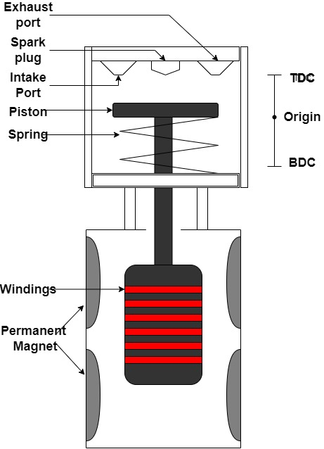

Figure 1.1 Free-Piston engine

Figure 1.1 shows various component of the FPLG as shown FPLG consists of ICE which converts energy released from fuel combustion into mechanical energy of the piston. The ICE is attached to the LEM where the mechanical energy of the mover is converted to electrical energy as per Faraday’s laws. Section 1.2.1 gives a detailed description of ICE part of FPLG and section 1.2.2 gives a detailed description of LEM of FPLG

### 1.2.1 ICE of FPLG

This section gives a component-by-component description of FPLG. The ICE part of a FPLG consists of a piston, intake and exhaust valves assembled in a combustion chamber attached to a mechanical spring for rebound actuation. Typically, simple FPLGs are spark-ignited two stroke engines which works on Otto cycle. The mechanical spring mechanism, although crude, produces viable actuation if spring of sufficient stiffness is used with proper control strategy.

### 1.2.2 LEM of FPLG

A typical LEM in FPLG is permanent magnet linear electric machine (PMLEM) [2]. These are classified into surface mounted PMLEM (SMPMLEM), transfer flux PMLEM (TFPLEM) and flux switching PMLEM (FSPLEM). SMPMLEM is a simple configuration which employs permanent magnet as a mover and surface-mount coil as a stator. SMPMLEM are further classified based on the direction of magnetization into radially magnetized, axially magnetized and quasi Halbach array type. The direction of magnetization in quasi Halbach PMLEM changes for every alternate pair of magnets. The performances of all the mentioned types have been studied [2], and it has been suggested that quasi Halbach PMLEM significantly improves efficiency. The PMLEM, are also classified based on topologies as tubular type and flat type PMLEM. Tubular type PMLEM generally has advantages in terms of simple structure and having zero net radial force. These however are difficult to manufacture. In many applications such as Hybrid Electric vehicles (HEVs) flat type PMLEM has advantages such as small space requirements [2].

## 1.3 WORKING OF FPLG

The working of FPLG can be compared to a conventional two stroke IC engine. During the Top Dead Center (TDC), which are determined by the compression ratio. During the expansion stroke the combustion force drives the piston from TDC to BDC and the LEM works as a linear generator. About half the generated power in LEM is absorbed by electric load and the other half is stored in compressed spring and the control system, which is used to rebound the piston to compression stroke. The LEM of FPLG although works as a linear generator during compression stroke, could also be used to provide motoring effect. This motoring effect can be used to implement motion error correcting mechanism.

### 1.4 CONTROL OF PISTON MOTION IN FPLG

The absence of crank removes constraints on stroke length due to crank’s geometry, which allows compression ratio to be varied as per requirements of the application. However, it complicates the motion control in free piston engines. In [2] the design and control issues of FPLG are reviewed. The most important issue regarding the piston motion control is to have precise value of the piston turnaround points (TDC/BDC). The common control strategies include fuel mass, air to fuel ratio and timing of closing and opening of valves as control variables. In [3] authors have used multilayer control to sustain the oscillations of piston, where LEM is used to adjust the output power of the FPLG. The set-point commands for TDC, BDC and velocity are determined according to the compression ratio requirements by a supervisory control layer. The set-point commands are used to determine the control variables in piston motion control layer. The error in velocity and position are fed back and these errors are reduced cycle-to-cycle by adjusting the mass of air fuel mixture. While efficient this strategy has with certain limitations which arises due to crude coupling between TDC value and mass of the air fuel mixture and lack of in-cycle piston motion control. An alternative to this approach is to use LEM current as a control variable. The latter method is called active LEM approach. Here a continuous force is applied to sustain oscillations and a nominal piston position trajectory is fed as the input. The availability of error correcting mechanism throughout the cycle increases robustness of FPLG.

## 1.5 OBJECTIVE AND SCOPE OF THE PROJECT

The primary objective of any control algorithm for FPLG is to ensure sustained oscillation of FPLG with desired compression ratio, precise piston position and velocity in presence of varying load and operating condition. The project will primarily be simulation based which aims to develop a dynamical model of FPLG, then apply principles of control theory to design a control algorithm using LEM current as a control variable and finally the control mechanism will be verified using the simulation model.

# SECTION 2FORCE MODELING OF FPLG

The motion trajectory of the piston is the resultant of the sum of instantaneous forces acting upon it. This section details the forces that work to move the piston in a FPLG. Each equation is described individually. The energy equations and their implications in deciding the stability of operation is also briefly touched upon in this section.

## 2.1 COORDINATE FRAME AND FORCE EQUATION

We will use mid of stroke as our reference point of the one degree of freedom coordinate system. We have assumed that direction from TDC towards BDC is positive, then the motion dynamics of FPLG can be described by the following equation

|  |  |
| --- | --- |
| $$M\frac{d^{2}x}{dt^{2}}=\left(F_{comb}+F_{m}+F_{sp}+F_{ad}+F_{vis}+F_{mu}+F_{g}\right)$$ | (2.1.1) |

Where $M$ is the mass of the mover, $F_{g}$ is the gravitational force, $F_{sp}$ is the spring force, $F_{m}$ is the magnetic force, $F_{comb}$ is the combustion force, $F_{vis}$ is the viscous friction force, $F_{mu}$ is the coulomb friction force, $F_{ad}$ is air drag force, $F_{sp}$ is the spring force and, $x$ is the position with respect to reference point. Figure 2.1 shows the piston motion, coordinate frame used and the reference direction of the forces on the mover mass described above.

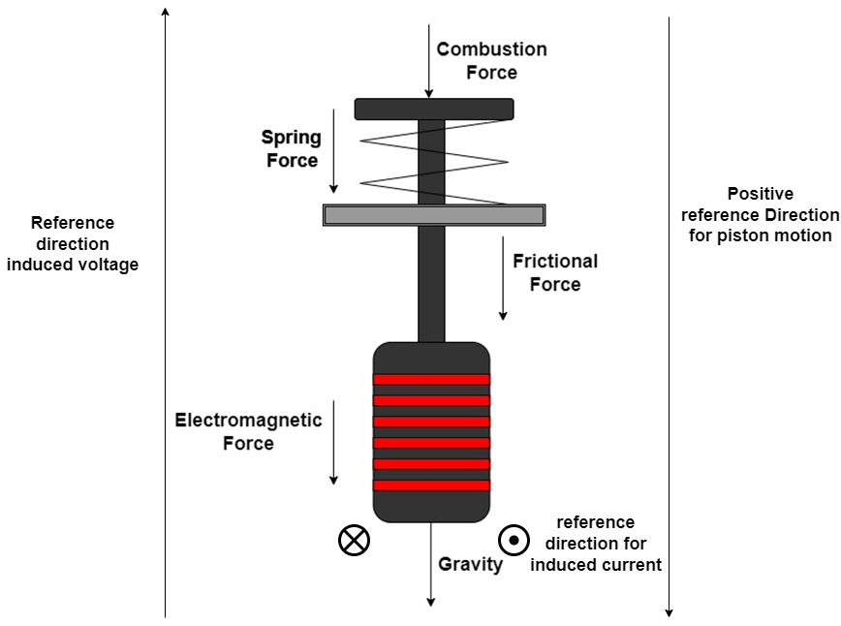

$$F_{comb}$$

$$F_{sp}$$

$$F_{m}$$

$$F_{ad}+F_{c}+F_{vis}$$

Figure. 2.1 Force diagram of mover of FPLG

2.2 COMBUSTION FORCE Spark ignited two stroke ICEs works on Otto cycle. The air fuel mixture is compressed adiabatically from BCD to TDC. Compression is followed by an isochoric ignition in a constant volume. The ignited fuel expands as an adiabatic process during the expansion stroke. Two stroke engines do not have dedicated intake and exhaust strokes. The fuel inlet port is opened towards the end of the expansion stroke. The fuel is then transferred to the combustion chamber via a transfer port. The exhaust port is opened simultaneously with the transfer port and burnt air fuel mixture is let out. Once the piston transits into compression stroke, the inlet, transfer and exhaust ports are closed in the order they were open. This process is called scavenging. The Pressure-Volume (PV) diagram shown in figure 2.1 shows the Otto cycle of an ideal two stroke engine.

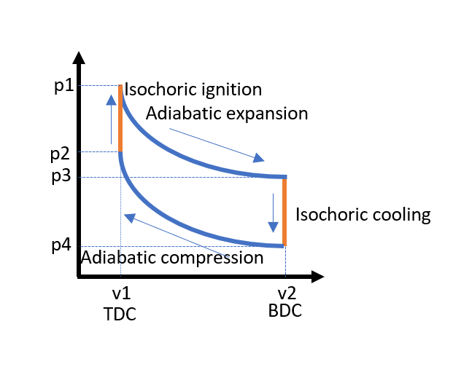

Figure 2.2 Two-stroke P-V diagram

The interaction of piston and gas differs in compression stroke and expansion stroke. In compression stroke the piston compresses the air-fuel mixture while in expansion stroke the ignited air fuel mixture exerts a force on the piston to drive it to BDC. The instantaneous force exerted by fuel gas on the piston is modelled by deferential pressure that acts on the piston. Let the pressure exerted by fuel gas on piston be $P_{C}$ and atmospheric pressure be $P_{atm}$. Then the instantaneous combustion force is given by:

|  |  |
| --- | --- |
| $$F_{comb}=A\left(P_{C}-P_{atm}\right)$$ | (2.2.1) |

where $A$ is the cross-sectional area of the piston. The fuel pressure $P_{C}$ depends upon the mass of air-fuel mixture that is burnt during each cycle. Applying laws of thermodynamics, the pressure $P_{C}$ is governed by the following equation

|  |  |
| --- | --- |
| $$\dot{P_{c}}=-\left(\frac{γ\dot{ν}}{ν}\right)P_{c}+\left(\frac{γ-1}{ν}\right)\dot{Q}$$ | (2.2.2) |

where $Q$ is the rate of energy released as heat during the combustion process, $ν$ is the instantaneous volume of air-fuel mixture, and $γ$ is the adiabatic constant which is the ratio of specific heat of fuel at constant pressure to specific heat of fuel at constant volume. The rate of energy released during combustion is given by:

|  |  |
| --- | --- |
| $$\dot{Q}=ηQ_{LHV}m_{f}{\dot{x}}_{β}$$ | (2.2.3) |

where $η$ is the combustion efficiency, $Q_{LHV}$ is the lower heating value, $m_{f}$ is the mass of the fuel, and $x_{β}$ is the fraction of mass burnt. The $x_{β}$ can be mathematically modeled as:

|  |  |
| --- | --- |
| $${\dot{x}}_{β}=6.908\frac{n+1}{T_{c}} {\left(\frac{t-t_{c}}{T_{c}}\right)}^{n}e^{-6.908{\left(\frac{t-t_{c}}{T_{c}}\right)}^{n+1}}$$ | (2.2.4) |

where $T_{c}$ is the duration of ignition, $t_{c}$ is the time of ignition and $n$ is the combustion quality index.

Equation (2.2.3) is important as it gives us the relation between the fuel mass and the energy imparted to the piston. This energy is partly transferred to the rebound device and partly delivered as useful work to the electrical load and control system during the expansion stroke. In the next section we will see the energy transfer during each stroke.

## 2.3 LEM MAGNETIC FORCE

Voice coil motors are often used for applications requiring precise motion control and faster dynamic response. The motor under discussion has a winding wrapped around a non-magnetic support material as a mover while two sets of NdFeB permanent magnet are used as the stator. The magnets are oriented in such a way so as to produce a net effect of a Halbach array. There has been some research done to improve the design and flux profile of LEM for applications requiring high current capacity using finite element analysis [5]. The report assumes linear magnetic circuit and uses simplified calculation for the mover mass and associated value of thrust coefficient, which is adequate for control system design.

The force exerted by LEM while working in motor mode is proportional to the cross product of flux and current

in the LEM. Assuming linear magnetic circuit with mutually orthogonal configuration, and neglecting effects of armature current the relation between force, flux density and current can be expressed as [5]:

|  |  |
| --- | --- |
| $$F_{m}=-BLI={-k}_{m}I, I=I_{load}+I_{ctrl}$$ | (2.3.1) |

where $B$ is the flux density generated in the air gap, $L$ is the length of conductor within the flux field, $I_{load}, I_{ctrl}$ are load and control current respectively and $k_{m}=BL$ is the thrust constant of the motor. The LEM converts the energy released from combustion into electrical energy. As described above half of the energy is stored in rebounding device. The other half is the sum of energy extracted as useful work and energy losses. The instantaneous current in the LEM consists of two components load current $I_{l}$ that is delivered to the load and control current $I_{ctrl}$ which corresponds to energy losses and the energy absorbed by control system during expansion stroke. The induced EMF in the LEM is directly proportional to velocity. Assuming linear magnetic circuit, and neglecting effects of armature current the voltage generated in LEM during regulation process is proportional to velocity and can be modeled as

|  |  |
| --- | --- |
| $$E_{ind}=BLv=k_{m}v$$ | (2.3.2) |

where $E_{ind}$ is the induced voltage in the coil and $v$ is velocity of the mover.

From equation (2.3.1) it follows that LEM can also be used to provide a motoring effect as discussed in the previous section, this motoring effect is used to implement error correcting mechanism. If an independent current source is used to provide the control current to LEM, we can assume a resistive load and by equation (2.3.1) we can simplify relation between magnetic force and current as

|  |  |
| --- | --- |
| $${ F}_{m}=-k_{m}I$$ | (2.3.3) |

Furthermore, as described in section 1.2.2 LEM provides a motoring effect which is used to control the piston motion the control current $I_{ctrl}$ in equation (2.3.1)corresponds to the said motoring effect

|  |  |
| --- | --- |
| $${ F}_{m}=F_{load}+F_{ctrl}$$ | (2.3.4) |

where, $F_{load}$ is force due to load current and $F_{ctrl}$ is force due to control current. The control current can be bifurcated into as shown

|  |  |
| --- | --- |
| $$I_{ctrl}=I_{store}+I_{loss}$$ | (2.3.5) |

where $I_{store}$ is current that corresponds to the energy absorbed by control system during expansion stroke while $I_{loss}$ is the current that corresponds to the energy that is needed to overcome frictional and other losses.

## 2.4 OTHER FORCES

### 2.4.1 Gravity

The gravity force is given by $F_{g}=Mg$, where M is the mass of the mover and $g$ is acceleration due to gravity. The effects of gravity will be replaced by frictional force due to gravity if the engine is placed horizontally. The piston will store some gravitational potential during the compression stroke when it moves in the anti-gravity direction. The stored gravitational potential is released as kinetic energy in next stroke. Thus, the net effect of gravity force per cycle is zero.

### 2.4.2 SPRING FORCE (REBOUND FORCE)

Mechanical springs are often used in FPLG as a rebounding device. Assuming for the purpose of simplicity that the spring is a linear spring, then the spring force can be modeled as:

|  |  |
| --- | --- |
| $${ F}_{sp}=-k_{sp}\left(x-x_{0}\right)$$ | (2.4.1) |

where $x$ is the instantaneous position of piston, $k_{sp}$ is the spring constant, and $x_{0}$ is the neutral position of the spring. In this report the neutral position of spring is chosen at mid-point of the stroke. The spring stiffness is to be carefully chosen and should be tuned to operational frequency for efficient operation as per the relation

|  |  |
| --- | --- |
| $$f_{o}=\frac{1}{2π}\sqrt{\frac{k_{sp}}{M}}$$ | (2.4.2) |

Where, $M$ is the mover mass.

### 2.4.3 FRICTIONAL FORCES

**Coulomb friction force**: Coulomb friction force acts in the direction opposite of velocity with a constant magnitude that is independent of velocity. This can be modeled as shown

|  |  |
| --- | --- |
| $${ F}_{c}=-µ_{k}fsgn(v)$$ | (2.4.3) |

where $µ_{k}$ is the kinetic coefficient of friction and $f$ is the normal force at the point of contact.

**Viscous friction**: The magnitude of viscous friction is linearly dependent on magnitude of velocity and is calculated as shown

|  |  |
| --- | --- |
| $${ F}_{vis}=-cv$$ | (2.4.4) |

where $v$ is the velocity and, $c$ is the viscous coefficient.

**Air drag**: The air drag acting upon the mover is directly proportional to the cross-sectional area and square of velocity. It is mathematically described as

|  |  |
| --- | --- |
| $$F_{ad}=\frac{{-C}_{d}Av^{2}}{2}$$ | (2.4.5) |

where $C_{d}$ is the drag coefficient, $A$ is the cross-sectional area and $v$ is the velocity.

Substituting all the forces in eq (2.1.1) the total equation of motion now becomes

|  |  |
| --- | --- |
| $$M\frac{d^{2}x}{dt^{2}}=Mg-k_{sp}\left(x-x_{0}\right)-k_{m}I+A\left(P_{C}\left(t\right)-P_{atm}\right)-µ_{k}fsgn(v)- cv-\frac{C_{d}Av^{2}}{2}$$ | (2.4.6) |

# SECTION 3 ENERGY MODELING OF FPLG

FPLGs like conventional ICEs are driven by energy released from the fuel by combustion. During the expansion stroke the FPE starts from TDC, a part of this energy is transferred to the rebound device and part of it is extracted as useful work.

|  |  |
| --- | --- |
| $$\underset{TDC→BDC}{W_{c}}=\underset{TDC→BDC}{W_{rd}}+E_{ex}+E_{loss}$$ | (3.1) |

where, $\underset{TDC→BDC}{W_{c}}$ is the work done by the fuel on the mover during expansion strokes, $\underset{TDC→BDC}{W_{rd}}$ is the sum potential energy in the rebound device at the end of expansion stroke and total energy transferred to control system during the expansion stroke, $E_{ex}$ is the useful work during expansion stroke and $E_{loss}$ is the energy loss due to air drag, mechanical frictions and electric losses, coil resistance losses and Eddy current loss. The rebound energy at the end of the stroke must be enough to send piston back to TDC. The rebound energy transferred to spring at the end of expansion stroke can be mathematically modeled as

|  |  |
| --- | --- |
| $$\underset{TDC→BDC}{W_{rd}}=\frac{k_{sp}{\left(x_{BDC}-x_{0}\right)}^{2}}{2}- \frac{k_{sp}{\left(x_{TDC}-x_{0}\right)}^{2}}{2}+\underset{TDC→BDC}{W_{ctrl}}$$ | (3.2) |

Where $\underset{TDC→BDC}{W_{ctrl}}$ is the energy transferred to control system during expansion stroke.

The combustion energy is a function of mass of air fuel mixture. Applying the laws of thermodynamics, the work done by the air fuel mixture on piston comes out to be

|  |  |
| --- | --- |
| $$\underset{TDC→BDC}{W_{c}}=\frac{\left(P_{ct}+{∆P}_{ct}\right)\left(V_{ct}^{γ}V_{cb}^{1-γ}+V_{ct}\right)}{1-γ}$$ | (3.3) |

where $P_{ct}$ is the pressure of air-fuel mixture at TDC just before ignition, $V_{ct}$ and $V_{cb}$ are the volume of combustion chamber at TDC and BDC, respectively, and $γ$ is the ratio of specific heat at constant pressure and constant volume. The relation between mass of air fuel mixture and output work is given by

|  |  |
| --- | --- |
| $${{∆P}_{ct}}_{c}=fH\left(m_{f}\right)=\frac{ηQ_{LVH}m_{f}R}{c_{v}V}$$ | (3.4) |

which provides a compelling case for $m_{f}$ to be used as a control variable. However, as fuel mass is injected only once in a cycle, any disturbance that occurs during the cycle cannot be immediately countered.

To have a symmetrical full wave functionality we choose our physical parameters in such a manner that half of combustion energy is transferred to the rebounding device and control system and the other half is extracted as electric output work. Most of the energy stored in rebounding device would be extracted as useful work in compression stroke giving us a full wave electric output.

During compression stroke the rebound energy stored in spring and energy provided by the control system pushes the piston to TDC, some of this energy is extracted as useful work and some is used to compress the air fuel mixture to the desirable compression ratio. The energy balance equation for compression stroke is

|  |  |
| --- | --- |
| $$\underset{BDC→TDC}{W_{rd}}=\underset{BDC→TDC}{W_{c}}+E_{cm}+E_{loss}$$ | (3.5) |

where, $\underset{BDC→TDC}{W_{rd}}$ is the work done by mechanical spring and control system to move the piston from BDC to TDC $,\underset{BDC→TDC}{W_{c}}$ is the work done by the mover assembly on air fuel mixture, $E_{cm}$ is the electrical output energy released during compression stroke. It is clear from equation (3.5) that rebounding device is not only used for compression but also to provide energy to the electrical load.

Now the energy for spring rebound device is given by

|  |  |
| --- | --- |
| $$\underset{BDC→TDC}{W_{rd}}=\frac{k_{sp}{\left(x_{TDC}-x_{0}\right)}^{2}}{2}- \frac{k_{sp}{\left(x_{BDC}-x_{0}\right)}^{2}}{2} +\underset{BDC→TDC}{W_{ctrl}}$$ | (3.6) |

Where $\underset{BDC→TDC}{W_{ctrl}}$ is the energy supplied by the control system during compression stroke.

The combustion energy is given by

|  |  |
| --- | --- |
| $$\underset{BDC→TDC}{W_{c}}=\frac{\left(P_{cb}\right)\left(V_{cb}^{γ}V_{ct}^{1-γ}+V_{cb}\right)}{1-γ}$$ | (3.7) |

It follows that the nominal values of energy storing elements such as spring stiffness and fuel mass are predefined for a stroke length and the desired useful work. Perturbations in the rebound device stiffness and fuel mass values can offset the nominal TDC and BDC values, which will be regulated by feedback control.

For AC circuits the complex power is produced in both resistive and reactive elements and thus manifest as phasor triangle governed by following equation.

|  |  |
| --- | --- |
| $$P_{complex}={jP}_{reactive}+P_{real}$$ | (3.8) |

where, $P_{reactive}$ is the rate of energy stored in reactive elements and $P_{real}$ is the power consumed in the resistive element. We have assumed a purely resistive electrical load thus $P_{reactive}$ can be assumed to be negligible as compared to $P_{real}$.The converted power $P_{conv}$ can be further defined as follows

|  |  |
| --- | --- |
| $$P_{conv}=F_{m}v$$ | (3.9) |

where $F_{m}$ is the magnetic force and $v$ is the piston velocity. From equation (3.9) and equation (2.3.1) we can write

|  |  |
| --- | --- |
| $$P_{conv}=k_{m}Iv$$ | (3.10) |

Where $k_{m}$ is the thrust constant of the Linear Electric Machine and $I$ is the current in the winding

Assuming a total resistance $R_{T}$ equation (3.3) can be further simplified as

|  |  |
| --- | --- |
| $$P_{conv}=\frac{k_{m}E_{ind}v}{R_{T}}$$ | (3.11) |

The resistance $R_{T}$ can be further bifurcated as shown in equation (3.12)

|  |  |
| --- | --- |
| $$R_{T}=R_{A}+R_{L}$$ | (3.12) |

where, $R_{A}$ is the resistance of the armature coil and $R_{L}$ is the electric load resistance.

From equation (3.11) and equation (2.3.2) we have our final equation as

|  |  |
| --- | --- |
| $$P_{conv}=\frac{E_{ind}^{2}}{R_{T}}$$ | (3.13) |

The converted power can be further bifurcated into load power which is extracted as useful power and power loss that occurs in armature coil. Thus, we get the following equation

|  |  |
| --- | --- |
| $$P_{conv}=P_{load}+P_{aloss}$$ | (3.14) |

where, $P_{load}$ is the useful power consumed by the load and $P_{aloss}$ is the power loss in the armature coil.

A simple voltage divider law can be applied to calculate $P_{load}$ and $P_{aloss}$ as shown in analysis that follows

|  |  |
| --- | --- |
| $$E_{load}=\frac{E_{ind}R_{L}}{R_{A}+R_{L}}=\frac{E_{ind}R_{L}}{R_{T}}$$ | (3.15) |

where $E_{load}$ is the voltage across the load ${ R}_{L}$ is the load resistance and $R_{A}$ is the armature resistance.

The electrical power in the load can be written as

|  |  |
| --- | --- |
| $$P_{load}=\frac{E_{l}^{2}}{R_{L}}=\frac{E_{ind}^{2}R_{L}^{2}}{R_{L}{\left(R_{A}+R_{L}\right)}^{2}}=\frac{E_{ind}^{2}R_{L}}{{\left(R_{T}\right)}^{2}}=\frac{P_{conv}R_{L}}{R_{T}}$$ | (3.16) |

Similar analysis provides the following equation for armature power loss

|  |  |
| --- | --- |
| $$P_{aloss}=\frac{P_{conv}R_{A}}{R_{T}}$$ | (3.17) |

The power analysis provides us relation between velocity and output power thus the cycle-to-cycle control problem of FPLG can be formulated as velocity regulation problem.

# SECTION 4PISTON MOTION CONTROL

## 4.1 STATE EQUATION OF FPLG

The motion of piston is a linear translative motion along a single axis, thus it is a one degree of freedom motion. The position and velocity are the state variables, and the forces acting on the piston are inputs which effects a change in velocity. The velocity in turn effects changes in position. The state equation of FPLG can be defined as

|  |  |
| --- | --- |
| ${\dot{x}}_{1}=x_{2}$ | (4.1.1) |
| $${ \dot{x}}_{2}=g-\frac{k_{sp}\left(x_{1}-x_{0}\right)}{M}-\frac{k_{m}I}{M}+\frac{A\left(P_{C}\left(t\right)-P_{atm}\right)}{M}-\frac{µ_{k}fsgn\left(x_{2}\right)}{M}-\frac{ cx_{2}}{M}-\frac{C_{d}Av^{2}}{2M}$$ | (4.1.2) |

where $x_{1},x_{2}$ are position and velocity respectively. The right-hand-side terms in equation (4.1.2) are the acceleration due to, respectively from left to right, gravity, rebounding spring, electromagnetic communication, Coulomb, viscous and air-drag forces acting on the piston. The external forces which drive the piston are the combustion force and the electromagnetic force. Thus, the two variables, i.e., the current in the stator coil that produces the magnetic force and fuel mass injected into the cylinder that produces the combustion force, can be used as control input for force allocation.



The spring in the model described above is an energy storing device and the energy stored in spring is used to rebound piston from BDC to TDC during compression stroke. The direction of kinetic friction force is always opposite to the sliding motion. It is due to the contact between two surfaces. The frictional force dissipates the energy provided to the piston. The viscous friction just as kinetic friction dissipates energy. The magnitude of viscous friction as described in previous sections is linearly related to the velocity of piston. Thus, some amount of energy transferred to piston is derived as useful work, some is stored in rebounding device and control system and some is lost due to friction and other losses. In order to sustain the oscillatory motion of piston the energy loss has to be replenished. In the following section a motion control strategy for FPLG is discussed.

## 4.2 MOTIVATION

It follows from equation (4.1.1) and equation (4.1.2) that the velocity at the nominal value of dead centers must be zero for achieving desired functionality. The acceleration however goes through zero and reverses polarity at dead centers. Moreover, as the system is sensitive to cycle-to-cycle variations, the controlling action will not only depend upon the dead center errors of previous cycle but also on the disturbances that happens during the cycle. TDC error implies pressure during combustion is not optimal to smoothly drive the piston to BDC and BDC error indirectly impacts TDC. Typical approach to design controller that uses feedback of TDC and BDC errors is ineffective in responding to in-cycle disturbances. In this project we have used position control where we use instantaneous position and velocity of the piston are used as feedback variables and LEM current as a control variable for in-cycle error regulation. The mass of the air fuel mixture is used as a nominal control variable for the nominal power output, which is kept constant during the in-cycle regulation in the project. The controller gains are calculated using Proportional-Integral (PI) controllers as described in the following sections.

## 4.3 DESIGN PROCEDURE

An effective approach for trajectory tracking control is by using nested-loop control, also known as cascade control method. By this approach, the plant is expressed as a cascade of subsystems, and the output of a subsystem is used as a virtual control variable for the subsequent subsystem. Each subsystem can be designed separately as a low-order system, which may greatly simplify the design task.

If the plant dynamics and actuator dynamics have been specified, then the design starts from the innermost loop, with its closed-loop behavior synthesized and tuned to achieve the best performance permitted by the actuator bandwidth. The innermost closed-loop subsystem is then treated as the actuator for the next outer loop, and the design process repeats until the outermost loop is closed to yield the best achievable overall system performance allowed by the plant actuators and the design technique employed. For each loop, the design can be done either by the time-scale separation method based on the singular perturbation theory, in which the outer-loop closed-loop dynamics is synthesized to be 3-5 times slower than the inner-loop, or by the backstepping method which is an advanced nonlinear control design method which may achieve better overall performance at the cost of significantly more complex design and implementation costs.

On the other hand, if the overall system performance requirements have been specified and are mandatory, then the design starts from the outermost subsystem whose output is that of the overall system. Once its control input is designed, it will be treated as the command trajectory for the next subsystem track. To synthesize the outermost loop controller gains, the inner-loops are neglected by time-scale separation based on the singular perturbation theory, which requires that the inner-loop time response is sufficiently faster, or its closed-loop bandwidth is sufficiently higher, than those required for the outermost loop. This will eventually lead to the required bandwidth for the system actuators, or even necessitates a redesign of the plant dynamic characteristics. We have used the second method as explained in detail in following sections. The basic block diagram of the FPLG is given below:

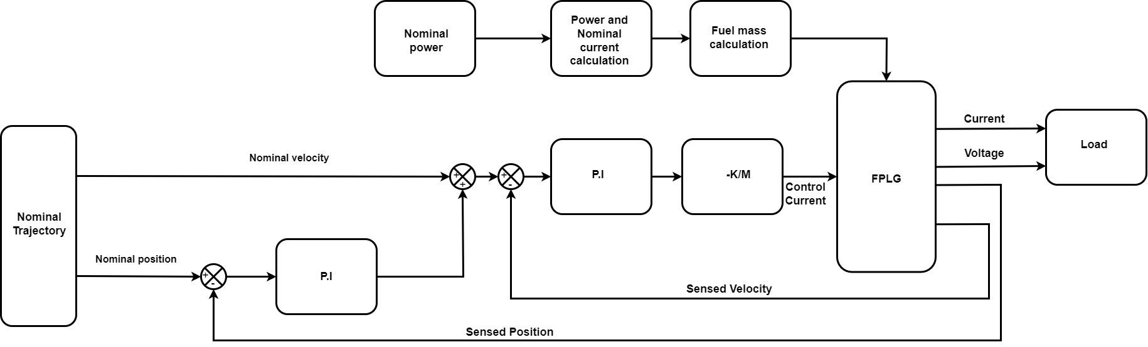

Figure 4.1 Nested loop controller

The nominal trajectory of the piston can be modeled as an orbitally stable limit cycle. In the context of two-dimensional state-space, periodic oscillations form a phase diagram that is a closed contour. The closed contour is known as a limit cycle. An orbitally stable limit cycle must enclose an unstable equilibrium.

## 4.3.1 NOMINAL CONTROL DESIGN

For this project the nominal power that is average power delivered to electrical load is chosen to be 15 kW and the operational frequency of engine is chosen to be 25 Hz. The output voltage is chosen to be 300 V RMS, and the load is assumed to be resistive. The power requirement may vary as per load. Thus, any load variation would be reflected in current variation only. This section explains the calculation of fuel mass from nominal power

The total energy required by the generator to complete one cycle is given by

|  |  |
| --- | --- |
| $$W_{total}=W_{load}+W_{loss}$$ | (4.3.1) |

where, $W_{total},W_{load}$ and $W_{loss}$ are the total energy provided to the generator, energy delivered to the electrical load, and energy losses occurred in one cycle, respectively.

Now,

|  |  |
| --- | --- |
| $$W_{total}=ηQ_{LHV}m_{f}$$ | (4.3.2) |

where $Q_{LVH}$, $η$ and $m_{f}$ are the lower heating value, efficiency, and fuel mass respectively.

The load energy can be described in terms of average power as shown in equation (4.3.3)

|  |  |
| --- | --- |
| $$W_{load}=P_{avg}T$$ | (4.3.3) |

where $P_{avg}$ and $T$ are the RMS load power and time period of operation respectively.

Equation (4.3.3) can be modified as

|  |  |
| --- | --- |
| $$W_{load}=\frac{P_{avg}}{f_{eq}}$$ | (4.3.4) |

where $f_{eq}$ is the frequency of operation.

For purely resistive load the average power can be further simplified as

|  |  |
| --- | --- |
| $$W_{load}=\frac{V_{rms}I_{rms}}{f_{eq}}$$ | (4.3.5) |

Substituting equation (4.3.2) and (4.3.5) in equation (4.3.1) we have

|  |  |
| --- | --- |
| $$ηQ_{LHV}m_{f}=\frac{V_{rms}I_{rms}}{f_{eq}}+W_{loss}$$ | (4.3.6) |

Equation (4.3.6) provides us with a simple linear relationship between $I_{rms}$ and $m_{f}$ which can be used to calculate the required fuel input. The modeling of $W_{loss}$ is complex and thus will be managed by feedback. Substituting $Q_{LHV}$ for petroleum as 44 j/mg and efficiency $η=$ 30%, the fuel mass per cycle can be determined for a given nominal power.

The nominal piston trajectory of the FPLG in this project is generated using Hopf supercritical oscillator. The supercritical oscillator can be described in polar form in a two-dimensional space by equation given below

|  |  |
| --- | --- |
| $$\dot{r}=r\left(μ-r^{2}\right)$$ | (4.3.7) |
| $$\dot{θ}=ω$$ | (4.3.8) |

where, $r≥0$ is the modulus i.e., Euclidean distance of the point describing the current state of the system from the unstable equilibrium of the limit cycle thus, $r≥0$ and $θ$ is the azimuth or polar angle. For $μ>0$ we can write from equation, (4.3.7) and (4.3.8) that

|  |  |
| --- | --- |
| $$\dot{r}\left\{\begin{matrix}>0 ∀r∈0,\sqrt{μ} \\ <0 ∀r∈\sqrt{μ},∞ \\ \dot{r}=0 , r=0,\sqrt{μ}\end{matrix}\right.$$ | (4.3.9) |

Equation (4.3.9) implies that the value of $r$ eventually converges to $\sqrt{μ}$ thus, the locus of phase diagram would be a circle of radius $\sqrt{μ}$.

Let us suppose point $p_{e}(α,β)$ as the equilibrium point for our piston motion system. Then, equation (4.3.7) can be converted into cartesian frame having coordinates $p(x_{1},x_{2})$ where $x_{1}$ and $x_{2}$ are the state variables using following derivation

|  |  |
| --- | --- |
| $$(x_{1}-α)=r\cos{(θ)}$$ | (4.3.10) |
| $$(x_{2}-β)=r\sin{(θ)}$$ | (4.3.11) |

From equation (4.3.10) and (4.3.11) we have

|  |  |
| --- | --- |
| $${\dot{x}}_{1}=\dot{r}\cos{(θ)}-r\sin\left(θ\right) \dot{θ}$$ | (4.3.12) |
| $${\dot{x}}_{2}=\dot{r}\sin{(θ)}+r\cos\left(θ\right) \dot{θ}$$ | (4.3.13) |

Substituting equation (4.3.7) and (4.3.8) in equation (4.3.12) and (4.3.13) we have

|  |  |
| --- | --- |
| $${\dot{x}}_{1}=r\left(μ-r^{2}\right)\cos{(θ)}-r\sin\left(θ\right)ω$$ | (4.3.14) |
| $${\dot{x}}_{2}=r\left(μ-r^{2}\right)\sin{(θ)}+r\cos\left(θ\right)ω$$ | (4.3.15) |
|  |  |

Substituting equation (4.3.10) and (4.3.11) in equation (4.3.14) and (4.3.15) we have

|  |  |
| --- | --- |
| $${\dot{x}}_{1}=(x_{1}-α)\left(μ-r^{2}\right)-(x_{2}-β)ω$$ | (4.3.16) |
| $${\dot{x}}_{2}=(x_{2}-β)\left(μ-r^{2}\right)+(x_{1}-α)ω$$ | (4.3.17) |

We know that,

|  |  |
| --- | --- |
| $$r^{2}={\left(x_{1}-α\right)}^{2}+{\left(x_{2}-β\right)}^{2}$$ | (4.3.18) |

Thus, equation (4.3.16) and equation (4.3.17) can be written as,

|  |  |
| --- | --- |
| $${\dot{x}}_{1}=(x_{1}-α)\left(μ-\left({\left(x_{1}-α\right)}^{2}+{\left(x_{2}-β\right)}^{2}\right)\right)-(x_{2}-β)ω$$ | (4.3.19) |
| $${\dot{x}}_{2}=(x_{2}-β)\left(μ-\left({\left(x_{1}-α\right)}^{2}+{\left(x_{2}-β\right)}^{2}\right)\right)+(x_{1}-α)ω$$ | (4.3.20) |

For, FPLG in our project the point $p_{e}(α,β)$ is considered as $p_{e}(\frac{s}{2},0)$ where $s$ is the stroke length.

The stability analysis of equation (4.3.19) and (4.3.20) can be done by linearizing those equations as shown

|  |  |
| --- | --- |
| $$\left[\begin{matrix}{\dot{x}}_{1} \\ {\dot{x}}_{2}\end{matrix}\right]=\left[\begin{matrix}\frac{∂f_{1}}{∂x_{1}} & \frac{∂f_{1}}{∂x_{2}} \\ \frac{∂f_{2}}{∂x_{1}} & \frac{∂f_{2}}{∂x_{2}}\end{matrix}\right]\left[\begin{matrix}x_{1} \\ x_{2}\end{matrix}\right]$$ | (4.3.21) |

where $f_{1}$ is ${\dot{x}}_{1}$  as described in equation (4.3.19) and $f_{2}$ is ${\dot{x}}_{2}$ as described in equation (4.3.20) thus we can write

|  |  |
| --- | --- |
| $$\left[\begin{matrix}{\dot{x}}_{1} \\ {\dot{x}}_{2}\end{matrix}\right]=\left[\begin{matrix}\left(μ-\left({3\left(x_{1}-α\right)}^{2}+{\left(x_{2}-β\right)}^{2}\right)\right) & -2\left(x_{1}-α\right)\left(x_{2}-β\right)-ω \\ ω-2\left(x_{1}-α\right)\left(x_{2}-β\right) & \left(μ-\left({\left(x_{1}-α\right)}^{2}+{3\left(x_{2}-β\right)}^{2}\right)\right)\end{matrix}\right]\left[\begin{matrix}x_{1} \\ x_{2}\end{matrix}\right]$$ | (4.3.22) |

at equilibrium point $p\left(α,β\right)$ equation (4.3.22) can be reduced to

|  |  |
| --- | --- |
| $$\left[\begin{matrix}{\dot{x}}_{1} \\ {\dot{x}}_{2}\end{matrix}\right]=\left[\begin{matrix}μ & -ω \\ ω & μ\end{matrix}\right]\left[\begin{matrix}x_{1} \\ x_{2}\end{matrix}\right]$$ | (4.3.23) |

The characteristic polynomial of equation (4.3.23) will be

|  |  |
| --- | --- |
| $${\left(λ-μ\right)}^{2}+ω^{2}=0$$ | (4.3.24) |

the roots $r_{1},r_{2}$ of equation (4.3.24) are

|  |  |
| --- | --- |
| $$r_{1}=μ+iω,r_{2}=μ-iω$$ | (4.3.25) |

Thus, for $μ>0$ the real parts of $r_{1}$ and $r_{2}$ are positive implying unstable equilibrium.

Furthermore, if we consider a candidate Lyapunov function as described in equation (4.3.26) below

|  |  |
| --- | --- |
| $$V\left(x\right)={\left(x_{1}-α\right)}^{2}+{\left(x_{2}-β\right)}^{2}-c$$ | (4.3.26) |

Then,

|  |  |
| --- | --- |
| $$\dot{V}(x)=\left[\begin{matrix}2(x_{1}-α) & 2(x_{2}-β)\end{matrix}\right]\left[\begin{matrix}{\dot{x}}_{1} \\ {\dot{x}}_{2}\end{matrix}\right]$$ | (4.3.27) |

Or

|  |  |
| --- | --- |
| $$\dot{V}(x)=\left[2\left(x_{1}-α\right) 2(x_{2}-β)\right]\left[\begin{matrix}(x_{1}-α)\left(μ-\left({\left(x_{1}-α\right)}^{2}+{\left(x_{2}-β\right)}^{2}\right)\right)-(x_{2}-β)ω \\ (x_{2}-β)\left(μ-\left({\left(x_{1}-α\right)}^{2}+{\left(x_{2}-β\right)}^{2}\right)\right)+(x_{1}-α)ω\end{matrix}\right]$$ | (4.3.28) |

Equation (4.3.28) can be simplified as

|  |  |
| --- | --- |
| $$\dot{V}(x)=2[\left({\left(x_{1}-α\right)}^{2}+{\left(x_{2}-β\right)}^{2}\right))\left(μ-\left({\left(x_{1}-α\right)}^{2}+{\left(x_{2}-β\right)}^{2}\right)\right)$$ | (4.3.29) |

The equation (4.3.29) suggests that $\dot{V}(x)<0$ when ${\left(x_{1}-α\right)}^{2}+{\left(x_{2}-β\right)}^{2}>μ$

The above conclusion coupled with the fact that the system has an unstable equilibrium point indicates that the state equation converges to a stable orbit whose locus is ${\left(x_{1}-α\right)}^{2}+{\left(x_{2}-β\right)}^{2}=μ$, as discussed above the value of $x_{1}$ and $x_{2}$ can be scaled to model the desired trajectory of the piston.

### 4.3.2 CLOSED LOOP CONTROLLER DESIGN

To synthesize the feedback control law first, we define the position tracking error as

|  |  |
| --- | --- |
| $$x_{err}=x_{com}-x_{sen}$$ | (4.3.30) |

where $x_{sen}$ is the sensed position

where for position loop

|  |  |
| --- | --- |
| $$x_{com}=x_{nom}$$ | (4.3.31) |

where $x_{nom}$ is generated by the nominal controller

From equation (4.1.1) we have

|  |  |
| --- | --- |
| $$\dot{x}=v$$ | (4.3.32) |

where $x$ and $v$ are position and velocity, respectively. Therefore, velocity can be used as a virtual control input $v_{com}$ which is required to move piston along the nominal trajectory. The velocity tracking command consists of two components

|  |  |
| --- | --- |
| $$v_{com}=v_{nom}+v_{ctrl}$$ | (4.3.33) |

where $v_{nom}$ is provided by the nominal controller, and $v_{ctrl}$ is required for correction of position tracking error. We can derive an error coordinate equation:

|  |  |
| --- | --- |
| $${\dot{x}}_{err}=v_{ctrl}$$ | (4.3.34) |

Equation (4.3.34) can be augmented with integral feedback as the state equation described below:

|  |  |
| --- | --- |
| $$\left[\begin{matrix}{\dot{x}}_{Ierr} \\ {\dot{x}}_{err}\end{matrix}\right]=\left[\begin{matrix}0 & 1 \\ 0 & 0\end{matrix}\right]\left[\begin{matrix}x_{Ierr} \\ x_{err}\end{matrix}\right]+\left[\begin{matrix}0 \\ 1\end{matrix}\right]v_{ctrl}$$ | (4.3.35) |

Where ${\dot{x}}_{Ierr}$ is the integral of the position error. The Position control law can be defined as:

|  |  |
| --- | --- |
| $$v_{ctrl}=K_{Px}x_{err}+K_{Ix}x_{ierr}$$ | (4.3.36) |

where $K_{Px}$ and $K_{Ix}$ are proportional and integral gains respectively. The equation (4.3.35) is already in controller canonical form. Thus, we do not need to perform matrix transformation. For the position control law defined in equation (4.3.36), $K_{px}$ and $K_{Ix}$ for a desired settling time and percentage overshoot can be derived using the Brass Gura method. The calculation for gains is described below.

We assume a general second order system:

|  |  |
| --- | --- |
| $$\left[\begin{matrix}{\dot{x}}_{Ierr} \\ {\dot{x}}_{err}\end{matrix}\right]=\left[\begin{matrix}0 & 1 \\ {-ω}_{n,x}^{2} & -2ζ_{x}ω_{n,x}\end{matrix}\right]\left[\begin{matrix}x_{Ierr} \\ x_{err}\end{matrix}\right]$$ | (4.3.37) |

Now for a desired percent overshoot $O_{s}$ we have:

|  |  |
| --- | --- |
|  | (4.3.38) |

Furthermore, for a 2% error tolerance, the settling time $T_{s,x}$ we have:

|  |  |
| --- | --- |
| $$ω_{n,x}≈\frac{4}{T_{s,x}ζ_{x}}$$ | (4.3.39) |

The gains can then s be calculated as:

|  |  |
| --- | --- |
| $$K_{Px}=2ζ_{x}ω_{n,x},K_{Ix}=ω_{n,x}^{2}$$ | (4.3.40) |

The procedure to calculate gains for inner velocity loop is similar to the one we have discussed for position loop. The velocity error can be defined as:

|  |  |
| --- | --- |
| $$v_{err}=v_{com}-v_{sen}$$ | (4.3.41) |

Where, $v_{sen}$ is the sensed instantaneous velocity and the $v_{com}$ is the sum of control velocity $v_{ctrl}$ and nominal velocity $v_{nom}$ generated by the nominal controller.

Following the same procedure described above we have:

|  |  |
| --- | --- |
| $$\left[\begin{matrix}{\dot{v}}_{Ierr} \\ {\dot{v}}_{err}\end{matrix}\right]=\left[\begin{matrix}0 & 1 \\ 0 & 0\end{matrix}\right]\left[\begin{matrix}v_{Ierr} \\ v_{err}\end{matrix}\right]+\left[\begin{matrix}0 \\ 1\end{matrix}\right]a_{ctrl}$$ | (4.3.42) |

The velocity loop PI control law can be written as:

|  |  |
| --- | --- |
| $$a_{ctrl}=K_{Pv}v_{err}+K_{Iv}v_{ierr}$$ | (4.3.43) |

where, $a_{ctrl}$ is the acceleration control input. The acceleration control is required to be added to nominal input for error correction. $K_{Pv}$ and $K_{Iv}$ are proportional and integral gains for velocity loop respectively. The gains $K_{Pv}$ and $K_{iv}$ can be calculated by similar analysis as described in (4.3.37) to (4.3.40).

We assume a second order system for velocity as shown in equation (4.3.44):

|  |  |
| --- | --- |
| $$\left[\begin{matrix}{\dot{v}}_{Ierr} \\ {\dot{v}}_{err}\end{matrix}\right]=\left[\begin{matrix}0 & 1 \\ {-ω}_{n,v}^{2} & -2ζ_{v}ω_{n,v}\end{matrix}\right]\left[\begin{matrix}v_{Ierr} \\ v_{err}\end{matrix}\right]$$ | (4.3.44) |

where $v_{Ierr}$ is the integral for velocity error.

Now for a desired percent overshoot $O_{s,v}$ we have:

|  |  |
| --- | --- |
|  | (4.3.45) |

Furthermore, for a 2% error tolerance settling time $T_{s,v}$ we have:

|  |  |
| --- | --- |
| $$ω_{n,v}≈\frac{4}{T_{s,v}ζ_{v}}$$ | (4.3.46) |

The gains can then be calculated as:

|  |  |
| --- | --- |
| $$K_{Pv}=2ζ_{v}ω_{n,v} , { K}_{Iv}=ω_{n,v}^{2}$$ | (4.3.47) |

Since the velocity loop is an inner-loop to the position feedback, its closed-loop dynamics will affect the stability of the position loop. Backstepping control method can be employed here to design the velocity loop while maintaining stability of the position loop. However, we will employ the time-scale separation (singular perturbation) principle here, which holds that for stability of the outer-loop, the inner-loop settling-time should be much faster than the outer loop. Finally, the control current required can be calculated as:

|  |  |
| --- | --- |
| $$I_{ctrl}=\frac{Ma_{ctrl}}{k_{m}}$$ | (4.3.48) |

# SECTION 5: PARAMETER CALCULATION AND SOFTWARE USED

## 5.1 PARAMETER CALCULATION

This section explains the calculation for selecting the physical parameters of the FPLG used for simulation demonstrating the control algorithm. For this report we have designed an FPLG with a 25 Hz sinusoidal electrical output for a nominal output power of 15 kW and RMS voltage of 300 V. The nominal electric load specifications are tabulated in Table 5.1.

Table 5.1 Nominal Electric Specifications

|  |  |
| --- | --- |
| Parameter | Value |
| Average electric output power of generator $P_{nom}$ | 15000 W |
| RMS output voltage $E_{nom}$ | 300 V |
| Output frequency $f_{o}$ | 25 Hz |
| Electrical load resistance $R_{L}$ | 6 Ω |
| Armature resistance $R_{a}$ Generator Efficiency $η_{e}$ | 0.3 Ω  0.95 |

Let $η_{e,nom}=P_{nom}/P_{conv,nom}$ be the efficiency of the electrical circuit of the LEM. Then the nominal converted power from the mechanical power and the armature resistance are given, respectively, by

|  |  |
| --- | --- |
| $$P_{conv,nom}=η_{e}^{-1}P_{nom}$$ | (5.1.1) |
| $$R_{a}=\left(η_{e}^{-1}-1\right)R_{L}$$ | (5.1.2) |

As discussed in section 2.2 the combustion energy released is dependent upon the lower heating value of the fuel. Furthermore, we know that rate of energy released is a function of duration of combustion and combustion quality index. Equation (2.2.2) provides the relation between the instantaneous pressure and rate of combustion energy released which requires the specific heat ratio or adiabatic constant. In order to determine the total mass of the mover, we also need to have the copper mass density $ρ_{cu}$ and assume a current density $σ_{cu}$ for the armature coil. The assumed values of these parameters are tabulated in Table 5.2.

Table 5.2. Assumed Design Parameters

|  |  |
| --- | --- |
| Parameter | Value |
| Piston mass ($M$) | 4 kg |
| Viscous friction coefficient () | 12 N/ms-1 |
| Specific heat ratio $(γ)$ | 1.32 |
| Lower heating value ($Q_{LHV}$) | 44 j/mg |
| Combustion quality index ($n$) | 2 |
| Duration of combustion ($T_{c}$) | 0.04 s |
| Piston cross section area ($A$) | 0.0082 m2 |
| Current density of copper ( | 6 A/mm2 |

With the parameters given in Tables 5.1 and 5.2, the remaining key design parameters, such as spring stiffness, coil mass, RMS nominal velocity and stroke length, can be determined as follows.

As discussed in section 2.4.2, the spring stiffness and mover mass are to be tuned to the operational frequency. We start with energy balance equation for a single cycle which is:

|  |  |
| --- | --- |
| $$\frac{P_{conv}}{f_{o}}=W_{load}$$ | (5.1.3) |

where $P_{conv}$ is the converted power, $W_{load}$ is the output energy of the system over one cycle, and $f_{o}$ is the operational frequency.

The mechanical energy converted to the electrical energy over one cycle is given by

|  |  |
| --- | --- |
| $$\frac{MV^{2}}{2}+\frac{k_{sp}X^{2}}{2}+W_{dis}=W_{cyc}$$ | (5.1.4) |

where, $M$ is the mover mass, $k_{sp}$ is the spring stiffness, $V$ is the RMS nominal velocity, $W_{dis}$ is the sum of energy provided by the mover to the electrical load and the energy dissipated in one cycle due to mechanical and electrical losses, $W_{cyc}$ is energy provided to the spring mass system every cycle, and $X$ is the RMS value of the amplitude of the sinusoidal mover displacement. The first term in equation (5.1.4) is the kinetic energy of the mover. The second term provides the value of potential energy stored in spring. The third term in equation (5.1.4) signifies the mechanical and electrical load and losses.

Once the steady oscillations are achieved, we can say that the exchange in kinetic and potential energy of mover mass becomes constant. Thus, external energy is required only to compensate for the losses and energy delivered to load depicted by $W_{dis}$ is equation (5.1.4). The energy balance during steady state is shown in equation (5.1.5) and equation (5.1.6)

|  |  |
| --- | --- |
| $$\frac{MV^{2}}{2}+\frac{k_{sp}X^{2}}{2}=K_{1}$$ | (5.1.5) |
| $$W_{dis}=W_{cyc}$$ | (5.1.6) |

where $K_{1}$ is a constant. Furthermore, $W_{dis}$ by definition could be decomposed into $W_{load}$ and $W_{loss}$, where $W_{loss}$ is the total energy loss in one cycle. Therefore,

|  |  |
| --- | --- |
| $$W_{cyc}=W_{loss}+W_{load}$$ | (5.1.7) |

By substituting equation (5.1.3) in equation (5.1.7) we have

|  |  |
| --- | --- |
| $$W_{cyc}=cV^{2}+\frac{P_{conv}}{f_{0}}$$ | (5.1.8) |

Where $c$ is the viscous coefficient. We have assumed stroke length of a commercial I.C engine with same output power. The velocity then can be calculated for further design. The stroke length is given in table 5.3. The stroke length $s$ is used to calculate velocity V in RMS value and the electromagnetic constant $k_{m}$ as shown in equation (5.1.9) and (5.1.10)

|  |  |
| --- | --- |
| $$s=2\sqrt{2}X=2\sqrt{2}\frac{V}{ω}$$ | (5.1.9) |
| $$k_{m}=\frac{E_{ind}}{V}$$ | (5.1.10) |

Now, for sinusoidal oscillation,

|  |  |
| --- | --- |
| $$k_{sp}=ω^{2}M$$ | (5.1.11) |

where $ω=2πf_{o}$ is the angular frequency of the oscillation. Furthermore,

|  |  |
| --- | --- |
| $$V=ωX$$ | (5.1.12) |

Now $M$ can be written as

|  |  |
| --- | --- |
| $$M=(M_{cu}+M_{piston})$$ | (5.1.13) |

where $M_{piston}$ is the piston mass, and

|  |  |
| --- | --- |
| $$M_{cu}=ρ_{cu}A_{cu0}L_{cu}$$ | (5.1.14) |

where is the mass of the copper coil, $ρ_{cu}$ is the copper mass density, $L_{cu}$ and $A_{cu}$ are, respectively, the total length and cross-sectional area of the copper wire for the armature coil. The cross-sectional area can be determined for a chosen current density $σ_{cu}$ by

|  |  |
| --- | --- |
| $$A_{cu0}=\frac{I_{nom}}{σ_{cu}}$$ | (5.1.15) |

The copper wire length can be determined from the electromagnetic constant $k_{m}$ of the LEM

|  |  |
| --- | --- |
| $$k_{m}=BL_{cu}=\frac{E_{ind}}{V}$$ | (5.1.16) |

where $E_{ind}$ is the induced voltage in the LEM given by

|  |  |
| --- | --- |
| $$E_{ind}=I_{nom}(R_{a}+R_{load})$$ | (5.1.17) |

where $I_{nom}$ is the nominal load current, $R_{a}$ is the armature resistance, and $R_{load}$ is the load resistance.

Thus, we can rewrite equation (5.1.8) as

|  |  |
| --- | --- |
| $$M=\left(M_{piston}+\frac{ρ_{cu}E_{ind}A_{cu}}{BV}\right)$$ | (5.1.18) |
| $$k_{sp}=ω^{2}M$$ | (5.1.19) | |

Using the design parameters in Tables 5.1-5.2, Equations (5.18)-(5.19) are solved using a MATLAB script shown in Appendix 2. Table 5.3 summarizes these derived parameters for the FPLG system.

Table 5.3 Derived Parameters

|  |  |
| --- | --- |
| Parameters | Values |
| Nominal RMS velocity ($V$) | 9.6 m/s |
| Mass of copper winding ($M_{cu}$) | 3.5 Kg |
| Total mass ($M$) | 7.5 Kg |
| Spring stiffness () | 1.85*105 N/m |
| Stroke length ($s$) | 0.12 m |
| Armature Resistance () | 0.3 Ω |
| Thrust coefficient () | 47.2 N/A |

## 5.2 Combustion Process:

The combustion process of a two-stroke ICE is a discontinuous process and is affected by the actuation of the intake, transfer, and exhaust ports. In this report Equations (2.2.4) and (2.2.3) are implemented in the SIMULINK model via a user defined function. Equation (2.2.2) is implemented as a state equation. The function uses instantaneous phase of piston position to trigger opening and closing of the valves and emulates isochoric cooling described in section 2.2. Another pulse which triggers the function for equation (2.2.3) is used to emulate the ignition process, which occurs at $20°$ before TDC. Figure 5.1 shows the trigger pulses with respect to the phase of the mover cycle according to the typical port timing for 2-stroke engines. Note that the effects of the inlet and transfer ports are ignored in the simulation, and the pressure drop at the end of the expansion stroke is realized as an exponential decay at the onset of the opening of the exhaust port, which is $60°$ before BDC and the low pressure is maintained over $120°$ until the close of the exhaust port. Figure 5.1 shows the opening and closing of exhaust port (EPO) as well as ignition timing (ign).



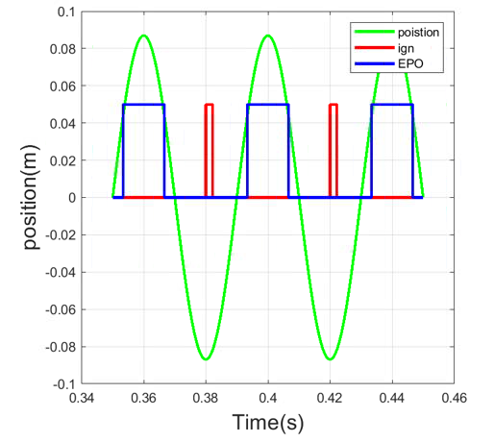

Figure 5.1 opening and closing of exhaust port

To verify the ICE model a pressure-position diagram which is a substitute of P-V diagram was also plotted which is shown in figure 5.2.

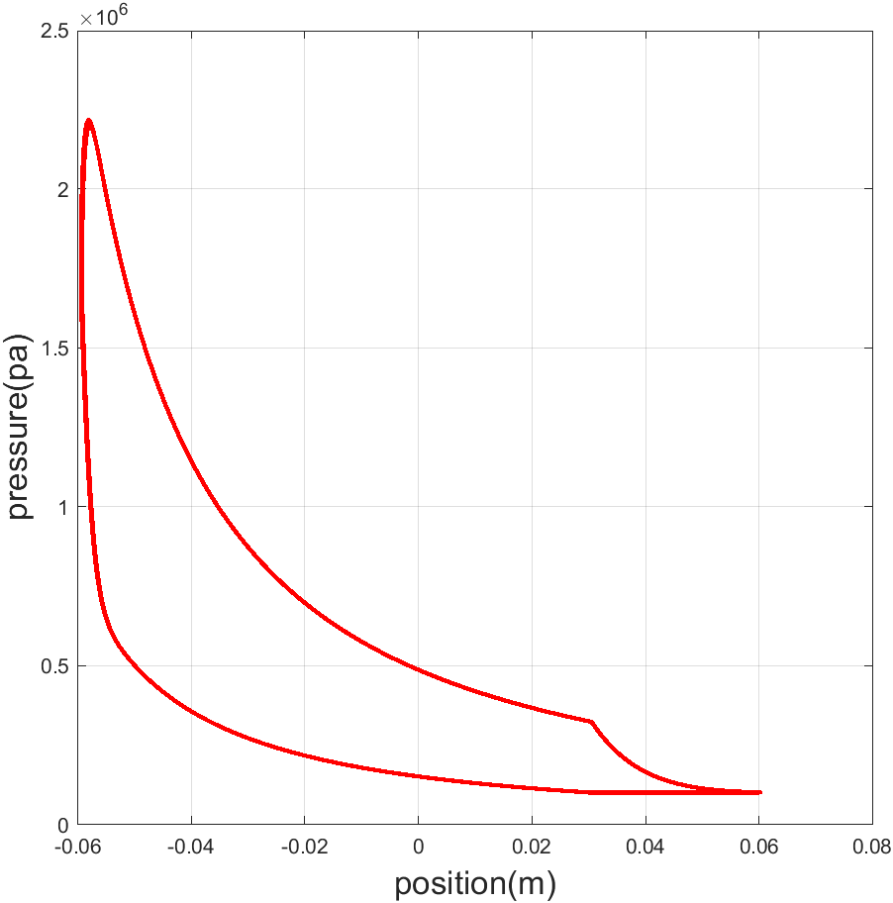

Figure 5.2 pressure vs position graph

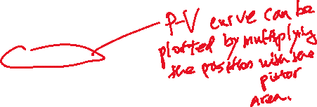

Instantaneous force can also be calculated. The force induced by the electric current is given below:























Now since electromagnetic force is being used as a control force therefore,

|  |  |
| --- | --- |
| $${ F}_{mctrl}=M\left(\overline{a}-a\right)$$ | (5.2.6) |















The values of parameter calculated as per procedure discussed above are tabulated below:

Table 5.4. Physical characteristics of FPE

|  |  |
| --- | --- |
| **Parameters** | **Values** |
| Moving mass | 7.5 (kg) |
| Spring Stiffness | 1.85*105 (N/m) |
| Piston Area | 0.0082 (m2) |
| Specific heat ratio | 1.32 |
| Top dead center | 10 (mm) |
| Bottom dead center | 130 (mm) |
| Thrust Constant ($k_{m}$) | 47.2 (N/A) |
| Fuel mass | 30 (mg) |
| Operating frequency | 25 (Hz) |
| Viscus coefficient | 12 (N/ms-1) |
| Load resistance | 6 (Ω) |
| Nominal output Power | 15 (kw) |
| Nominal output Voltage(rms) | 300 (V) |
| Nominal output current(rms) | 50 (Amps) |

## 5.3 MATLAB® AND SIMULINK® CODE:

A Simulink model was created to simulate the FPLG system with the proposed controller as designed. The SIMULINK model is based on physical force model discussed in section 2, which is nonlinear. The model was used to verify control law discussed in section 4. The MATLAB script code was used to create data structure of values used for initializing and running the simulation, and displaying results. The SIMULINK model and MATLAB script are included in Appendix 1 and 2, respectively.

A brief description of the Simulink model is included in this section. Figure 5.3 shows the Simulink model used for simulation.

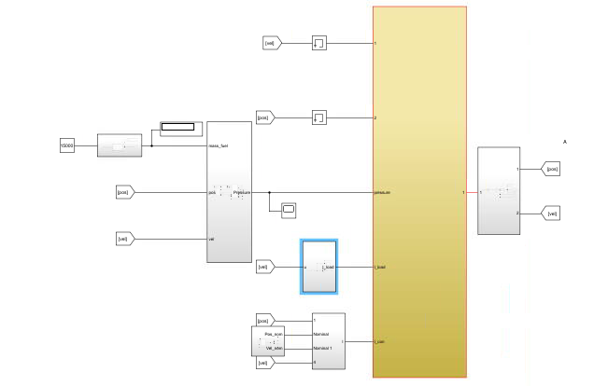

Figure 5.3. Simulink Model of FPLG

As shown in figure 5.3 the model contains seven subsystems for the combustion force model and controller. The total force acting upon the piston is calculated and divided by mass to compute acceleration. The acceleration is integrated to compute velocity which in turn is integrated to compute piston position. The simulations were performed using ODE 45 solver with tolerance of ${10}^{-3}.$ The following section includes simulation results performed to determine validity of the model as well as to verify the control law. A detailed SIMULINK model report is included in Appendix A.

# SECTION 6: SIMULATION RESULTS

## **6.1 SIMULATION OF FPE MODEL**:

The objective of this simulation is to verify correctness of the engine simulation model and combustion model. The combustion process can be verified by plotting burnt mass fraction and change in energy transferred to the engine. The burnt mass fraction goes from zero to one during the combustion time. The relation between energy delivered and mass fraction burnt is given in equation (2.2.3). The model was simulated for 0.5 sec at 25 Hz to verify the same.

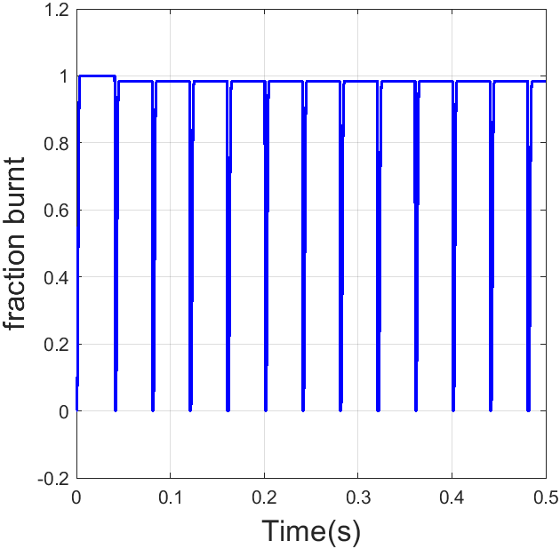

Figure 6.1 fuel fraction burnt vs time

The mass fraction burnt goes from 0 to 1 within the combustion time. The combustion energy released is proportional to the differential of fraction burnt as we have discussed in (2.2.3). Figure 6.2 shows the combustion energy plotted against time.

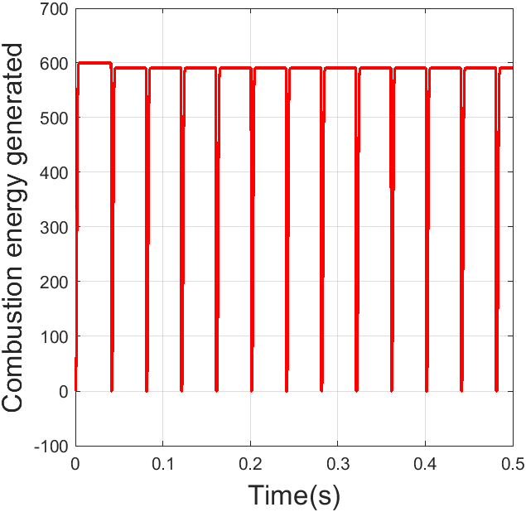 Figure 6.2 Combustion Energy Released

The combustion happens in a fraction of second which increases the pressure of air fuel mixture to drive the piston down. Therefore, the combustion force as expected is an impulse, which releases a certain amount of energy instantly. The pressure was modeled using state-space method. Since (2.2.2) suggests that rate of change in pressure depends upon instantaneous value of pressure, integrator was used to simulate the pressure. The rest of the model is based on physical addition of forces rather than state space equation. ,as shown in Figure 6.3.

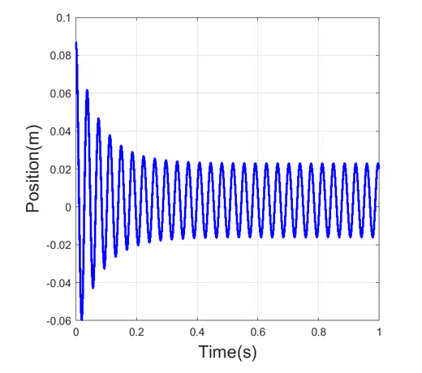

Figure 6.3 position vs time for uncontrolled operation

## 6.2 NESTED LOOP CONTROLLER SIMULATION

The purpose of this simulation is to verify the reference trajectory tracking algorithm described above using a nested loop controller. The nested loop design was simulated for the following transient parameters:

Outer loop parameters:

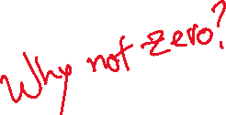

where is the percentage overshoot, $T_{so}$ is the settling time for the outer loop and $f_{eq}$ is the engine frequency. The outer loop settling time is just logical requirement as the engine will complete one stroke in half of the time period.



Inner loop parameters:



where is the percentage overshoot $, T_{si}$ is the settling time for inner loop and $f_{eq}$ is the engine frequency.

Here the inner loop was designed with settling time which was 3 times faster than the outer loop. The simulation was performed which produced following results.

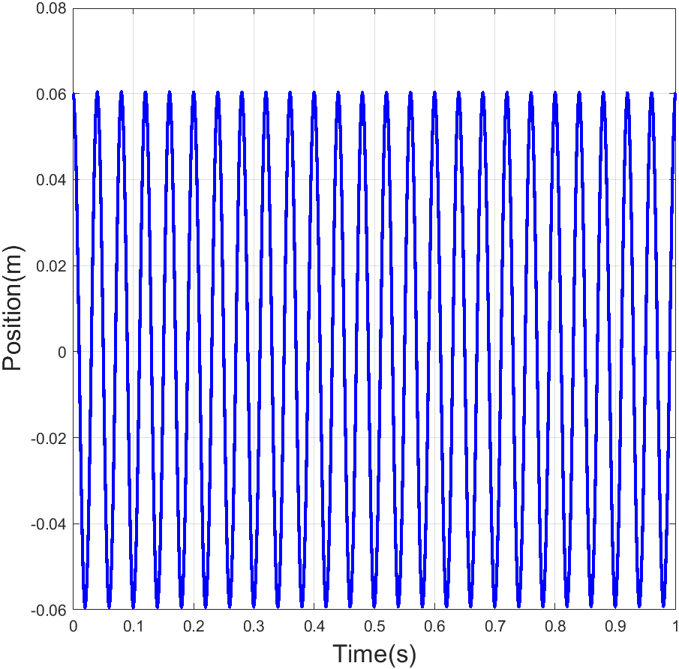

Figure 6.4 position vs time

As shown in the figure 6.4 sustained oscillations could be achieved by using nested loop method for tracking error dynamics that is linearized along the nominal trajectory of the piston motion. As the error correcting mechanism is available throughout the cycle the working of engine is robust. However, for the quoted Transient response parameters the FPLG produces a BDC error which is a small offset in BDC position at the end of the expansion stroke. This error may cause misfire in certain situations. A comparison of nominal position and actual position is shown figure 6.5.

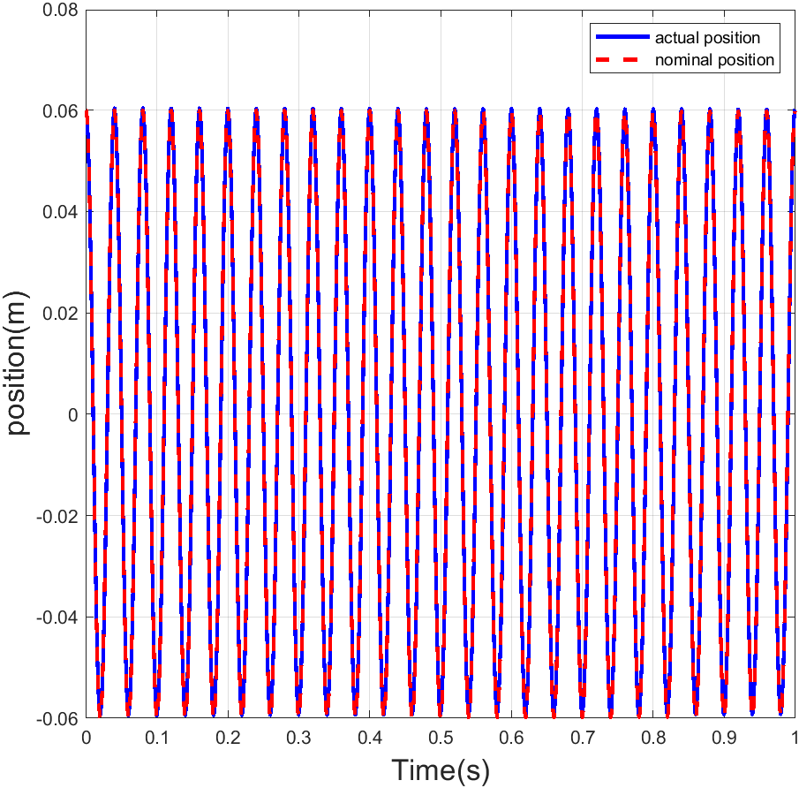

Figure 6.5 actual position vs nominal position.

The velocity and the phase curve are depicted in figure 6.6 and figure 6.7, respectively.

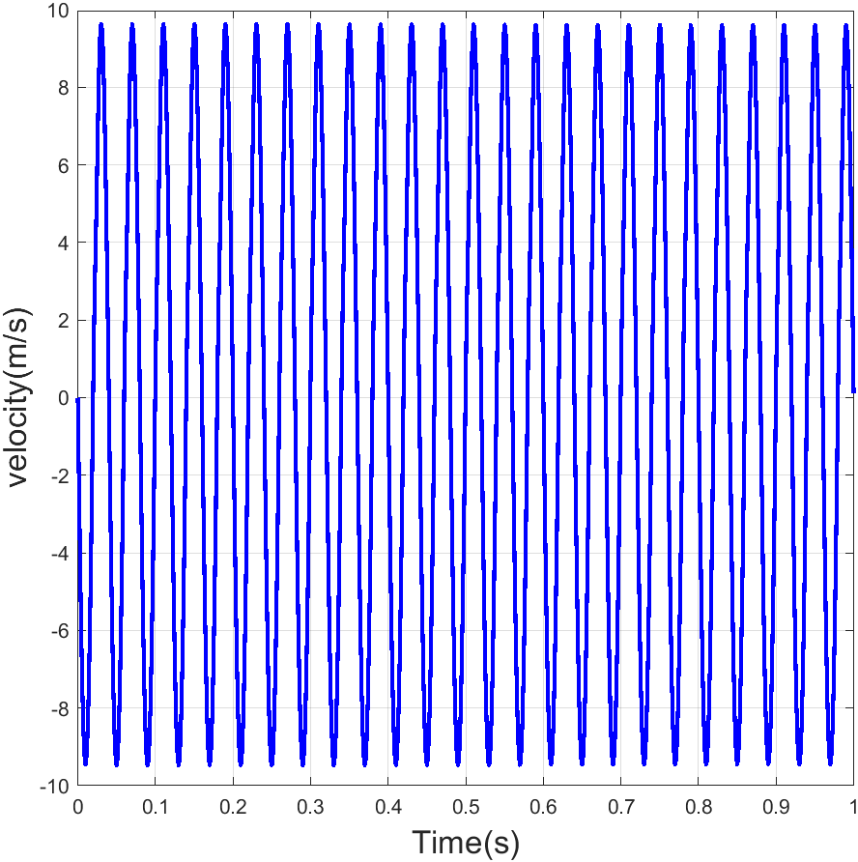

Figure 6.6 piston velocity vs Time

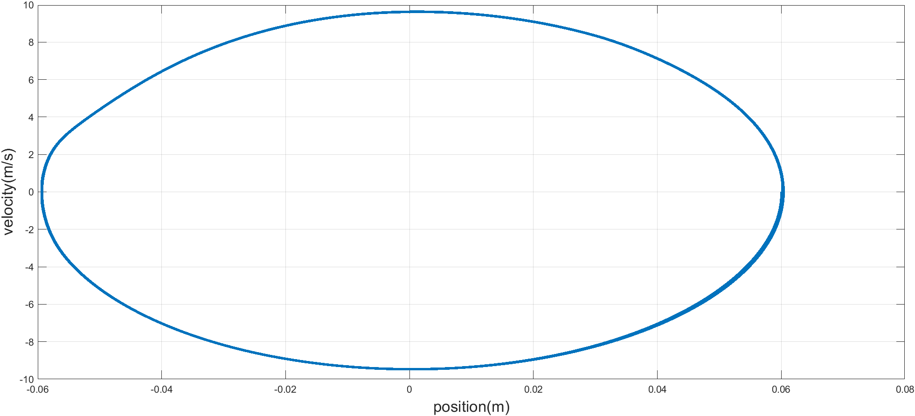

Figure 6.7 phase diagram velocity vs position

Figure 6.8 shows comparison between actual velocity and nominal velocity.

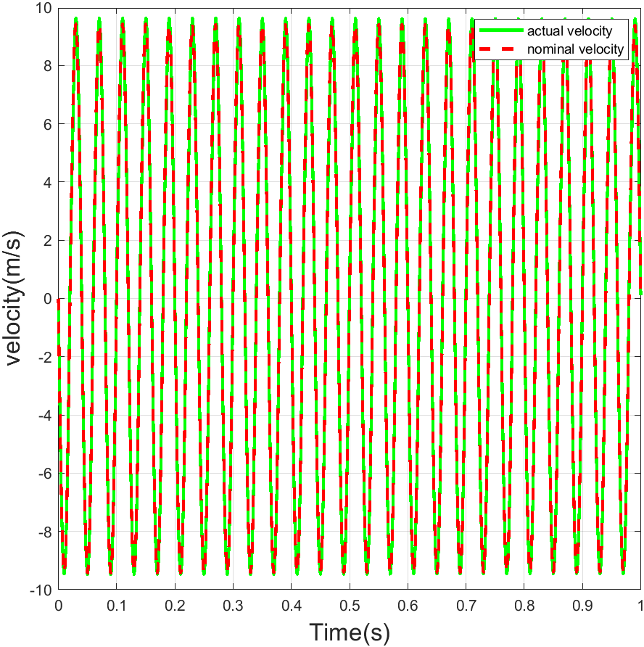

Figure 6.8 actual velocity vs nominal velocity.

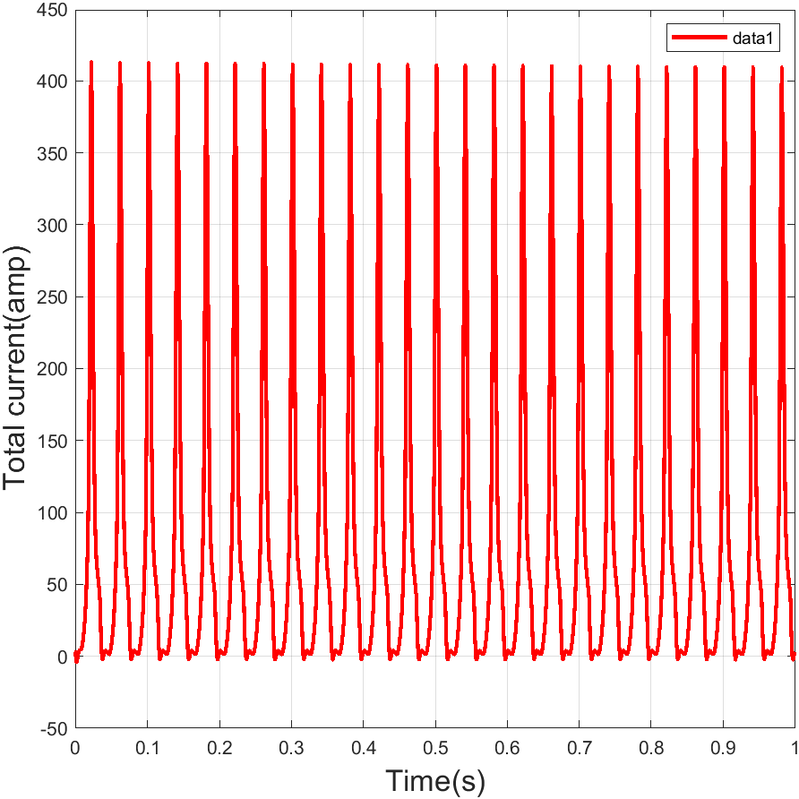

Figure 6.9 Current vs time

Figure 6.9 shows total current in the LEM. As discussed in section 2.3 total current has two components, load current and control current. The values of load current and control current were separately plotted in figure 6.10 and it was verified that the load current is a sinusoidal wave.

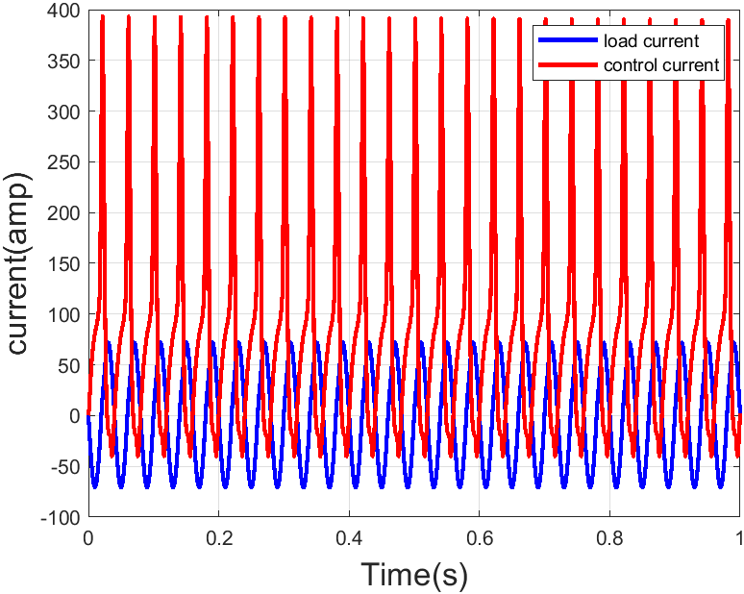

Figure 6.10 control/load current vs time

The RMS value of load current is 49.96A against 50 A as desired. Thus, the load current error is 0.08%. Control current represents control effort that is required to correct trajectory tracking errors, overcome energy losses, and store half of the electric energy for the load during the expansion stroke that is released during the compression stroke. The RMS value of control current is 131.1 A. The voltage produced in LEM is proportional to velocity. Figure 6.11 shows voltage vs Time plot. The RMS value of voltage is 299.8. Figure 6.12 shows Control power vs Time plot.

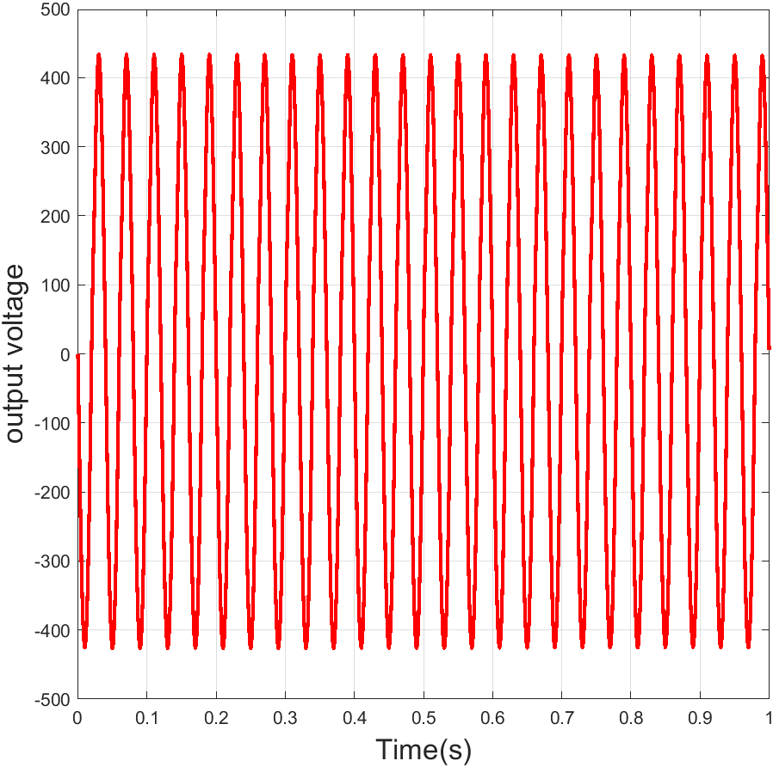

Figure 6.11 Voltage vs Time

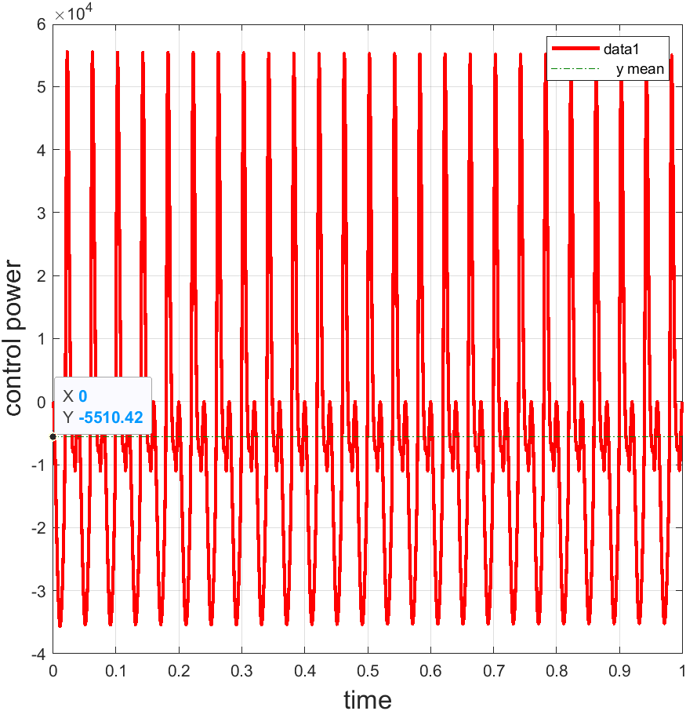

Figure 6.12 Control power vs Time

The Output power that is the power absorbed by load is shown in Figure 6.13. The simulation suggests that the average output power of the generator is 14978.9 W against 15000 W nominal value.

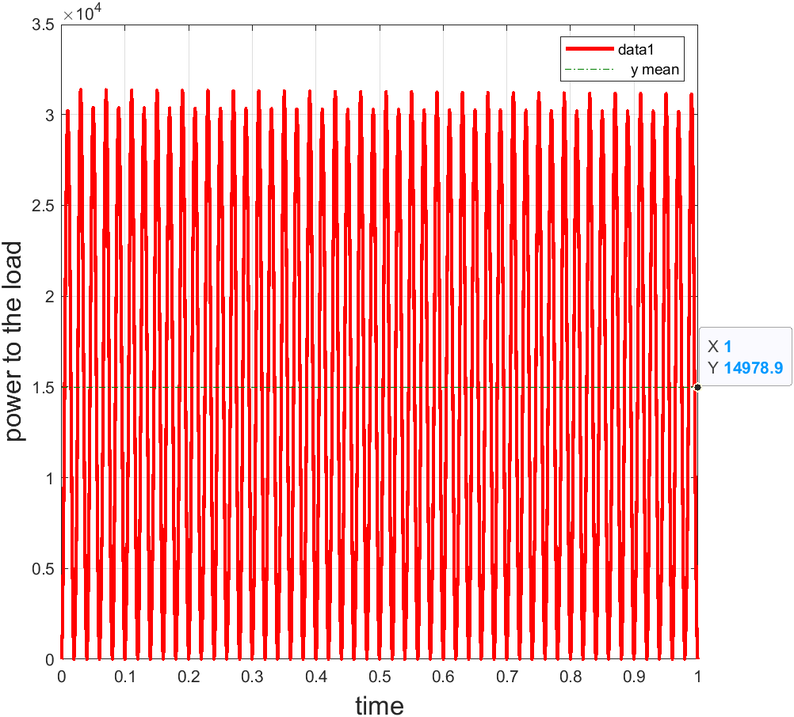

Figure 6.13 power to load vs time

Control current is used for correction of velocity and position trajectory errors. Figure 6.12 and 6.13 shows position and velocity error respectively.

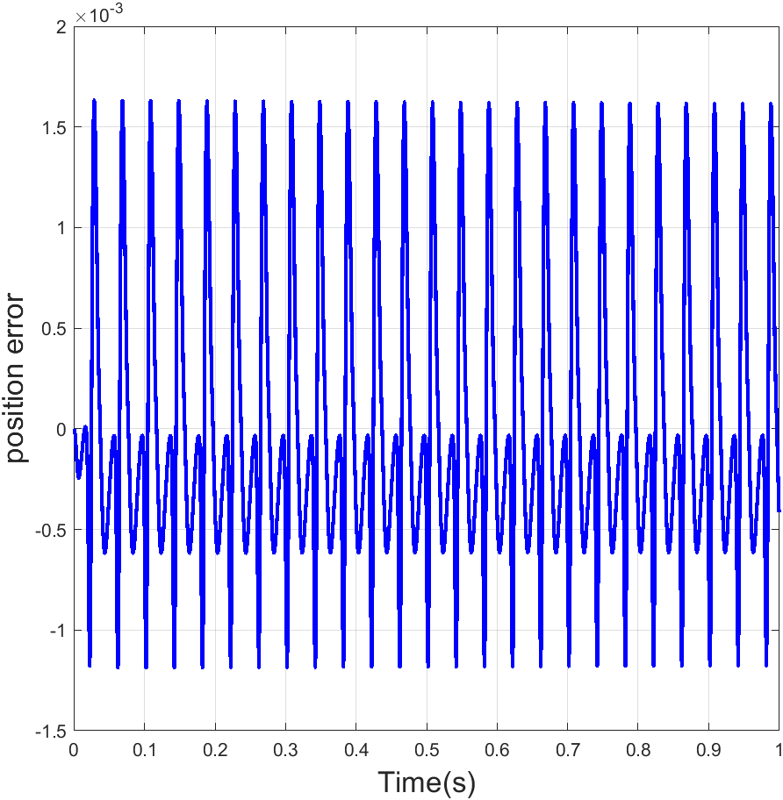

Figure 6.14 position error vs time

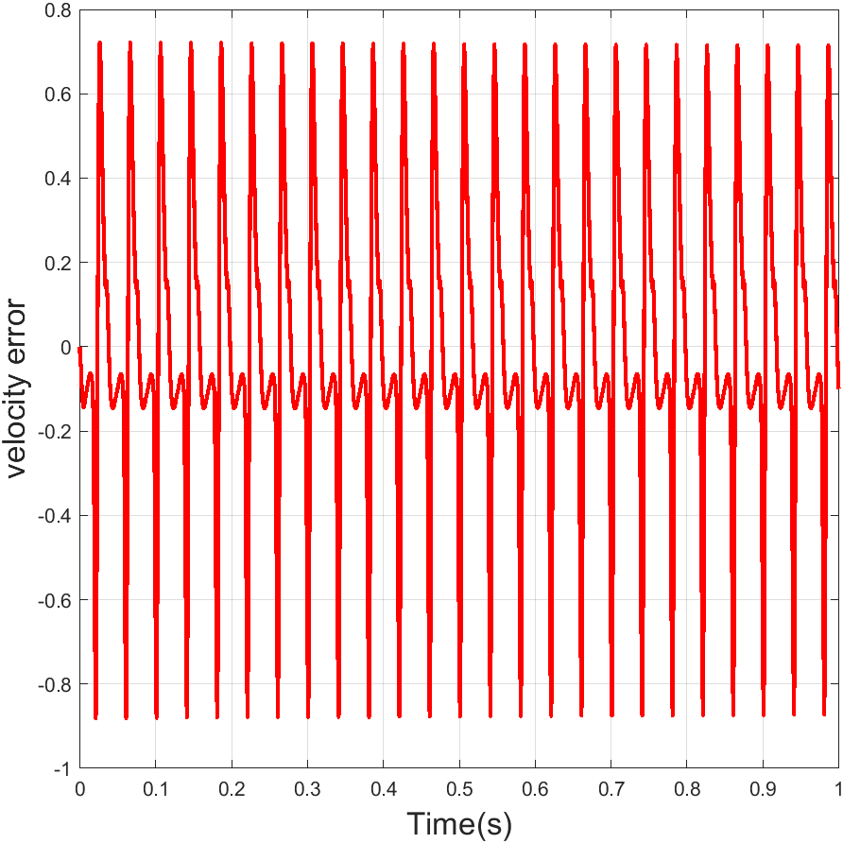

Figure 6.15 velocity error vs time

To simulate active LEM, control the mass of air fuel mixture injected in each cycle was kept constant throughout the simulation and expansion and compression processes were considered adiabatic.

The pressure increases exponentially during the compression stroke until the piston reaches the TDC value. The timing of ignition alters the maximum pressure which forms the basis of combustion parameter control. To keep the maximum current value within reasonable bounds, the ignition was performed closer to TDC. The pressure curve is shown in Figure 6.16.

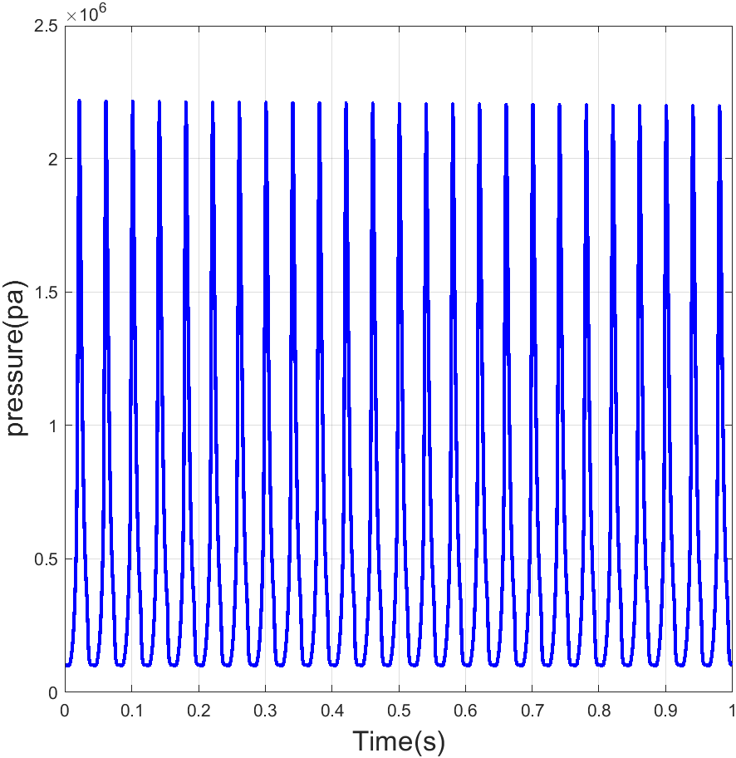

Figure 6.16 pressure vs time

Some of the advantages of nested loop control method are easy computation of control law and modularity in design. The electromagnetic force is the reaction force to the combustion force less the mechanical losses. In this project electromagnetic force was used to provide error correction and combustion force was used to drive the piston and the electric load. Figure 6.17 shows the instantaneous magnetic force compared to Combustion force. The simulation gives expected results with combustion force which is the main driving force having higher magnitude.

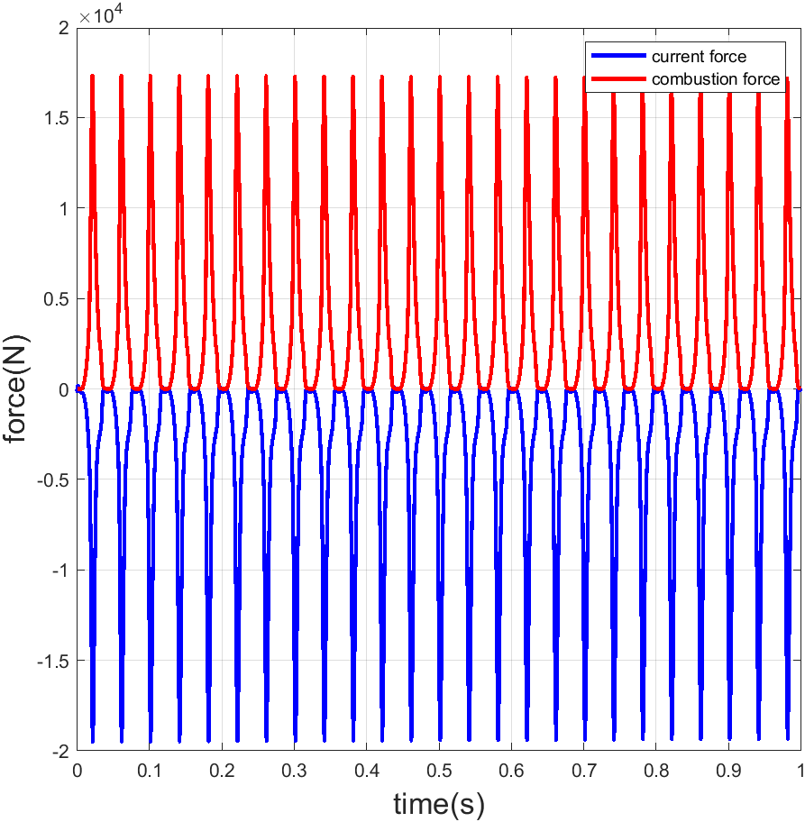

Figure 6.17 Electromagnetic/combustion force vs time

# SECTION 7 SUMMARY AND FURTHER STUDY

The fundamental objective of this project was to design a FPLG for a given nominal output power and voltage. Section 5.1 discusses the selection of FPLG parameters to achieve the same. Furthermore, a non-linear oscillator was used to generate piston nominal trajectory. The nested loop control strategy to sustain the operation of FPLG was developed in section 4.4. A Simulink model was simulated to verify design and control algorithm and the results of the simulation were included in section 6. The controlled piston motion was as expected sinusoidal.

The report discusses various configuration of linear generator in section 1.2.2. The advantages and disadvantages of each configuration was briefly discussed. The current and force requirements often place significant constraints on linear machine design. High current values imply high current density. Typically, the current density of conductors at room temperature ranges from 4A/mm2 to 6A/mm2, for most common conductors this would lead to unreasonably high wire cross section of wire for peak current values. The LEM design and geometry must be able to support high force density. Furthermore, the motor geometry can affect the output power characteristics. Flux leakages can significantly alter the LEM performance. Accurate determination of these physical parameters requires finite element analysis and experimentation.

Hysteresis and eddy current losses must also be analyzed to achieve efficient operations of FPLG. FPEs are not only employed in hybrid electric vehicles as range extenders but also to provide multifuel functionality. One area of study regarding FPE is variable compression ratio and ability to perform Homogeneous charge ignition (HCCI functionality).

# REFERENCES

# 

1. R. Mikalsen, A.P. Roskilly, “A review of free-piston engine history and applications,” Sir Joseph Swan Institute for Energy Research, Newcastle University, Newcastle upon Tyne, NE1 7RU, England, UK, February. 17 2009
2. Xuezhen Wang, Feixue Chen, Renfeng Zhu, Guilin Yang and Chi Zhang, “A Review of the Design and Control of Free-Piston Linear Generator,” *Energies,* August 20, 2018
3. R. Mikalsen, A.P. Roskilly, “The control of a free piston engine generator. Part 1: Fundamental analysis,” Sir Joseph Swan Institute for Energy Research, Newcastle University, Newcastle upon Tyne, NE1 7RU, England, UK, January.18, 2010
4. Chi Zhang, Feixue Chen, Long Li, Zhaoping Xu, Liang Liu, Guilin Yang, Hongyuan Lian, Yingzhong Tian, “A Free-Piston Linear Generator Control Strategy for Improving Output Power”, *Energies,* January 5, 2018
5. Zhaoping Xu, Siqin Chang, “Improved Moving coil Electric Machine for Internal Combustion Linear Generator,” IEEE transactions on energy conversion June, 2010

# APPENDIX 1 SIMULATION MODEL OF FPLG

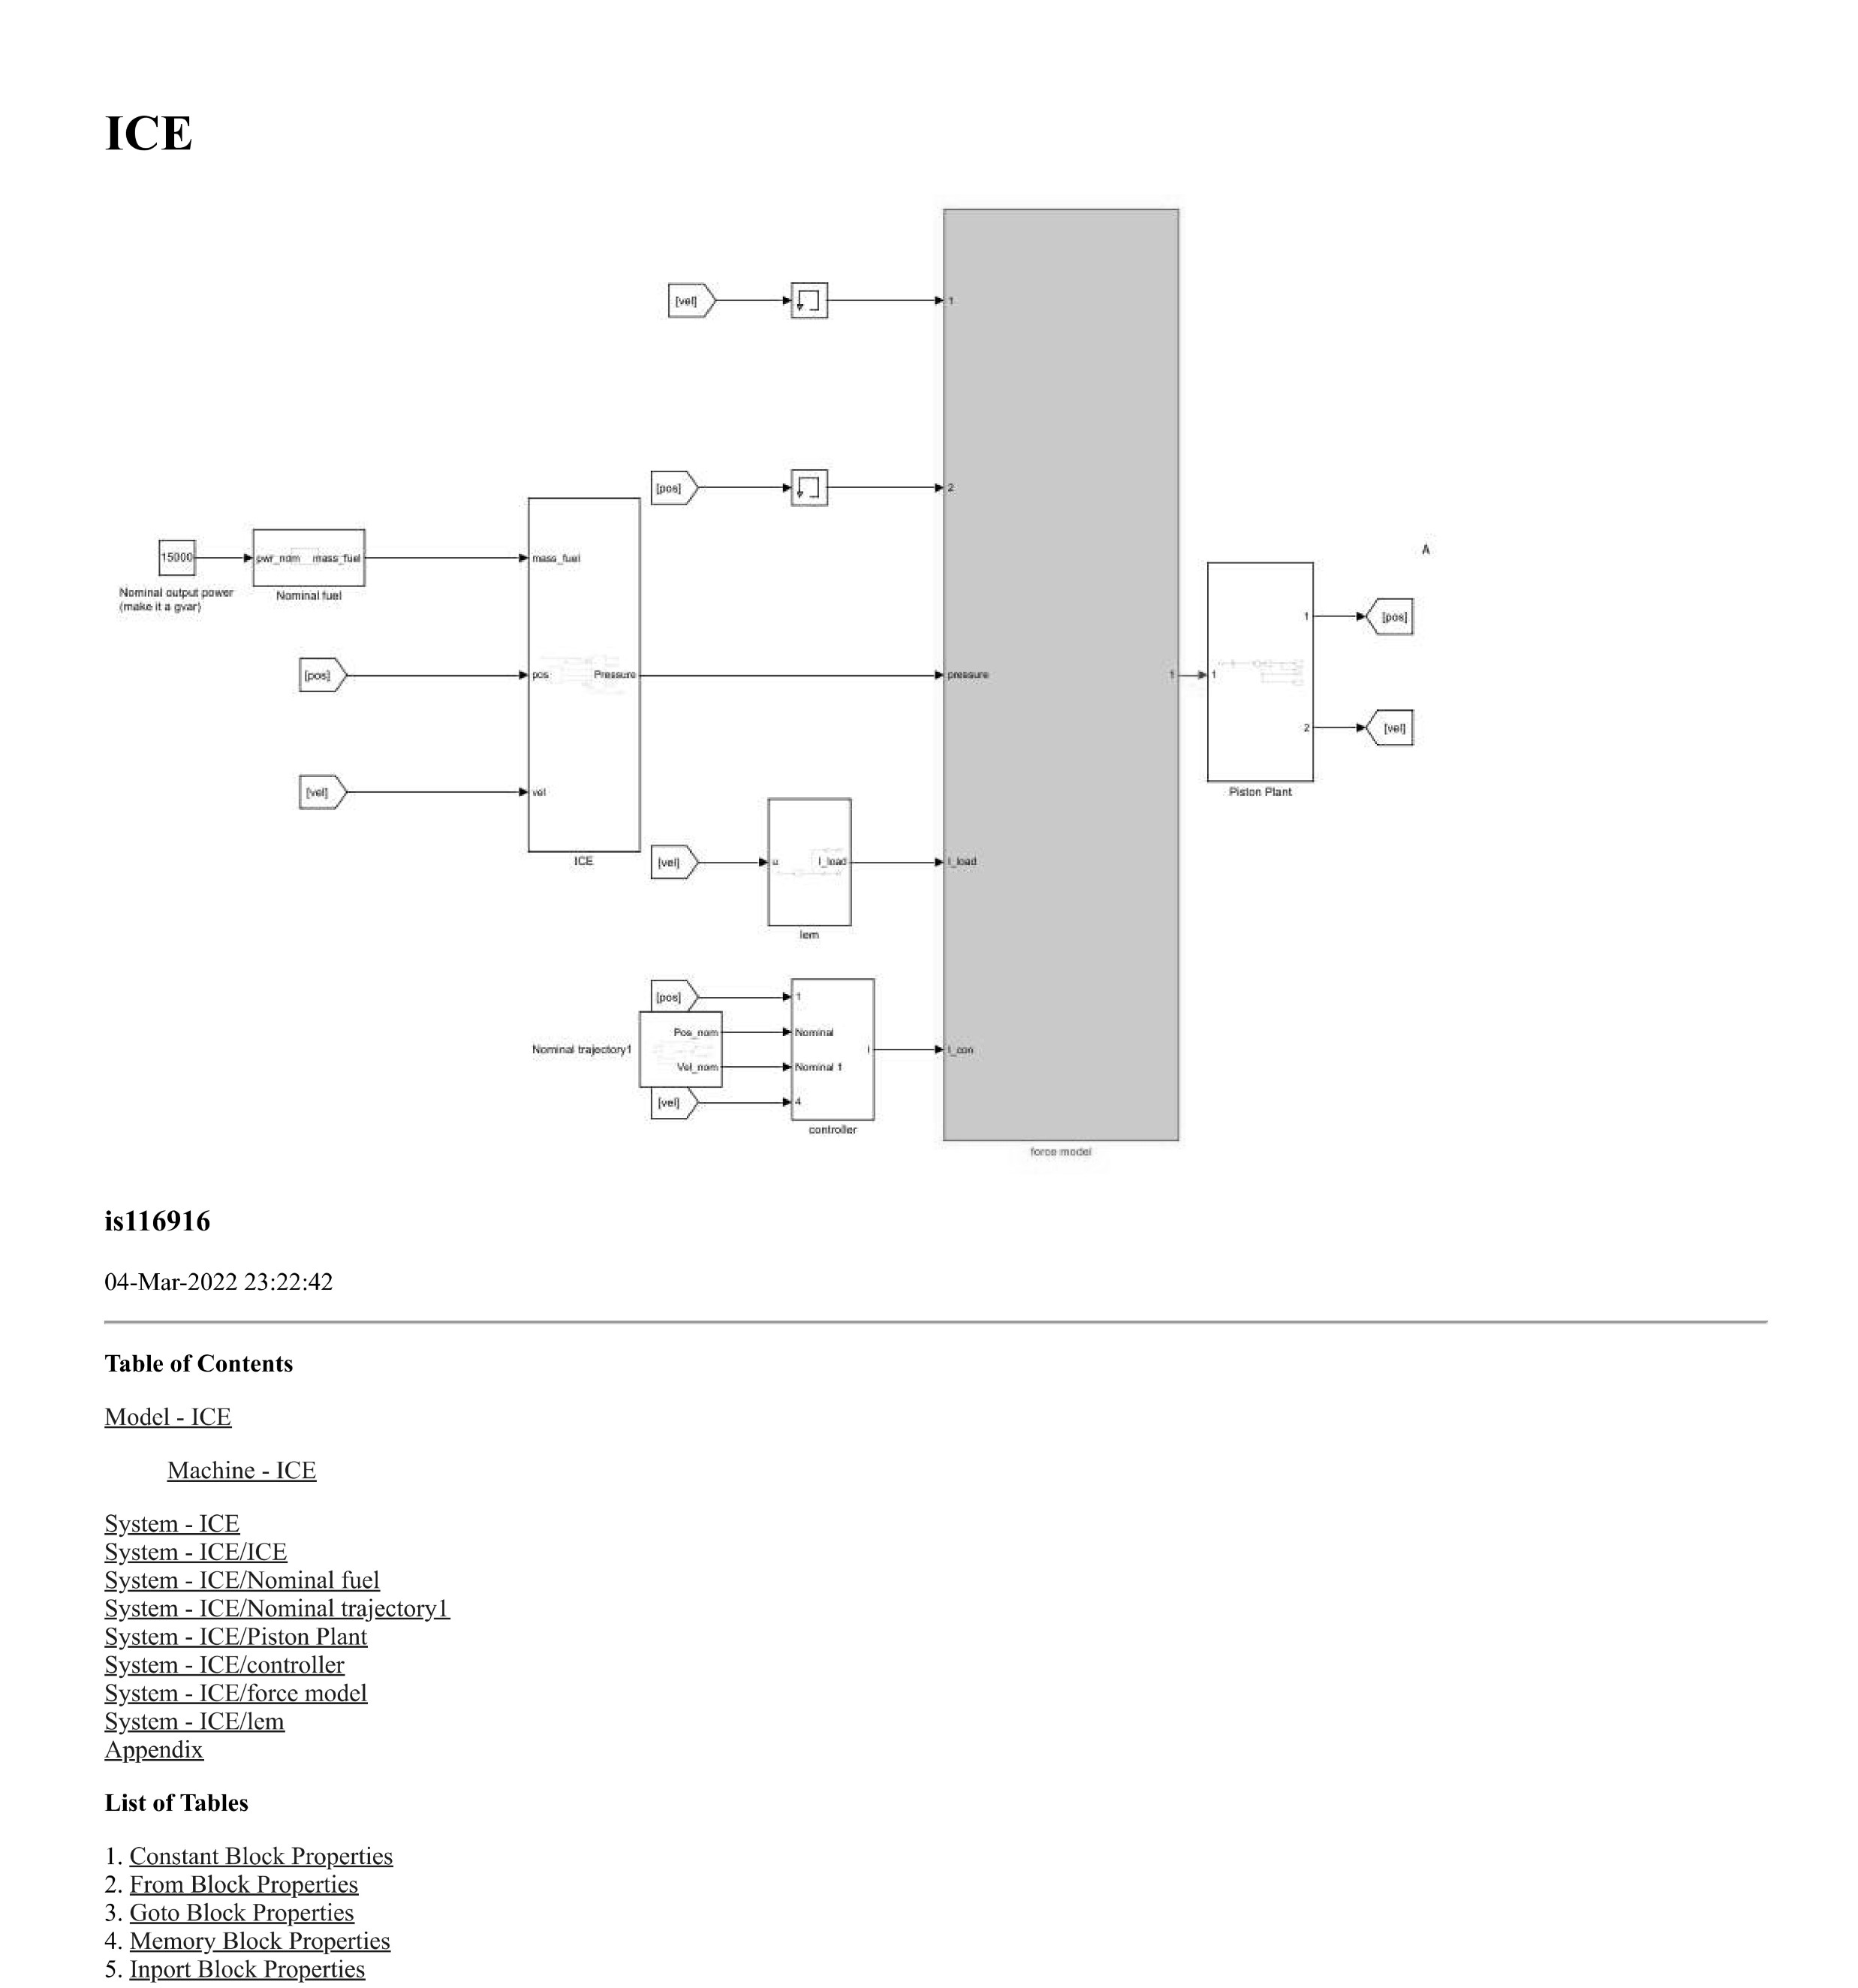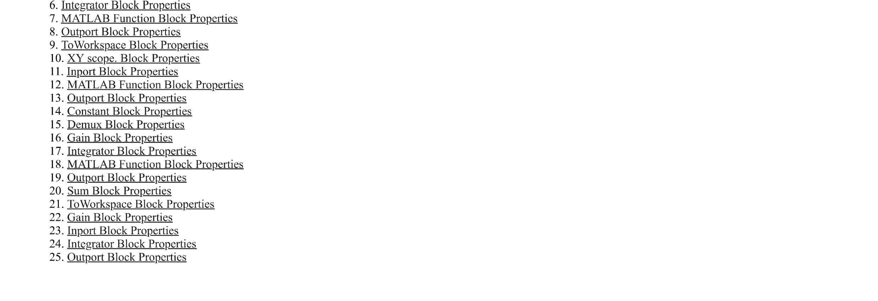

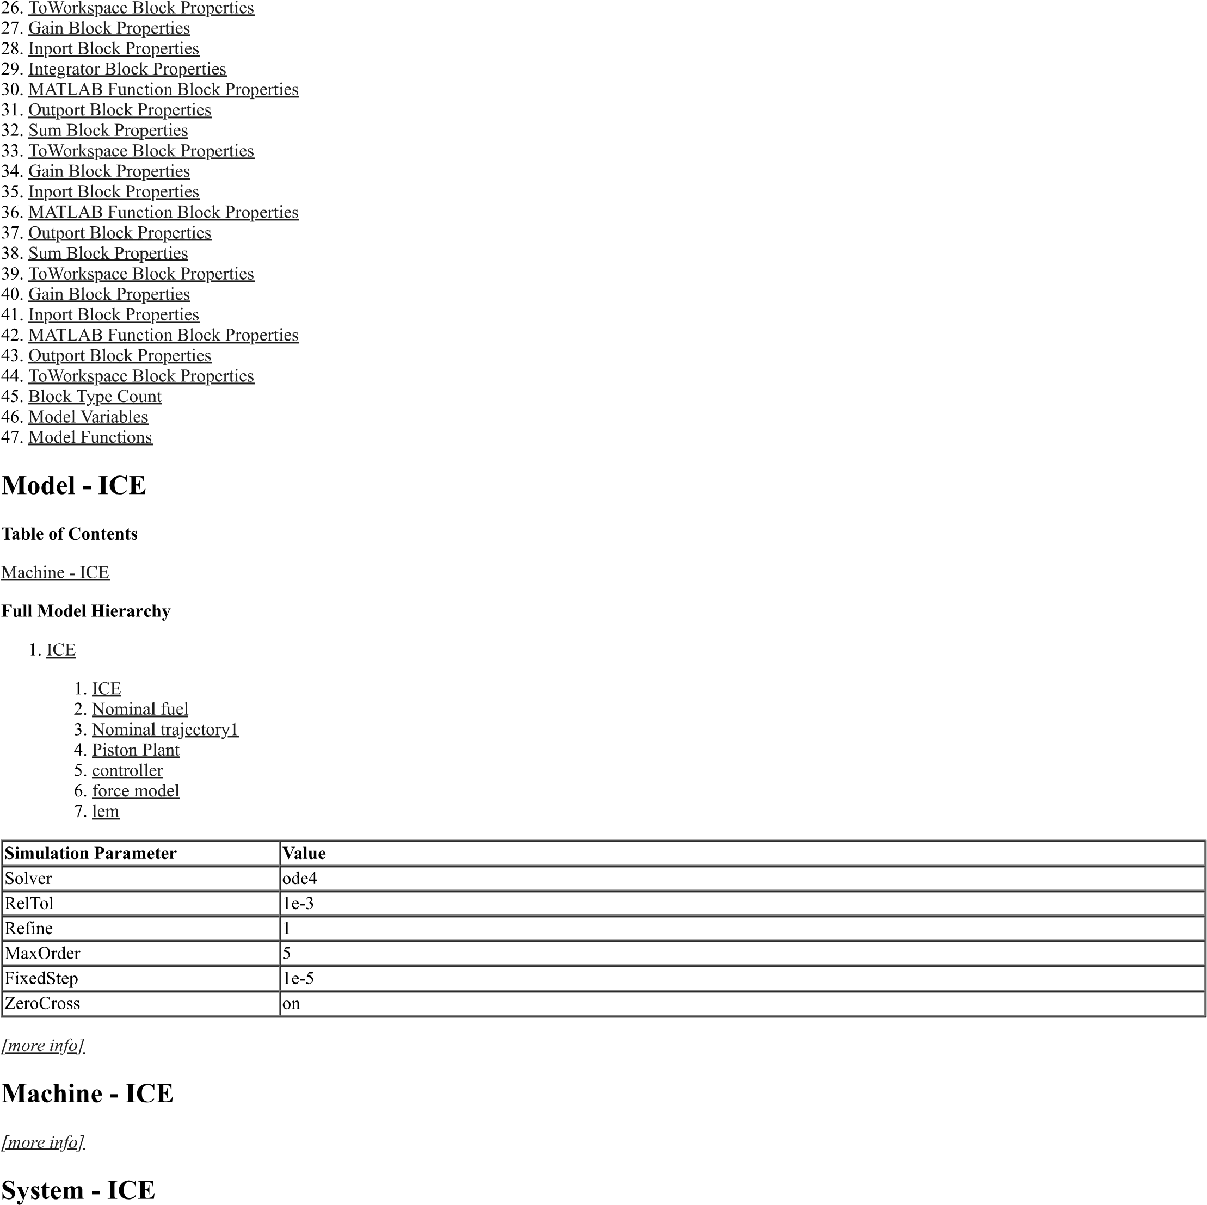

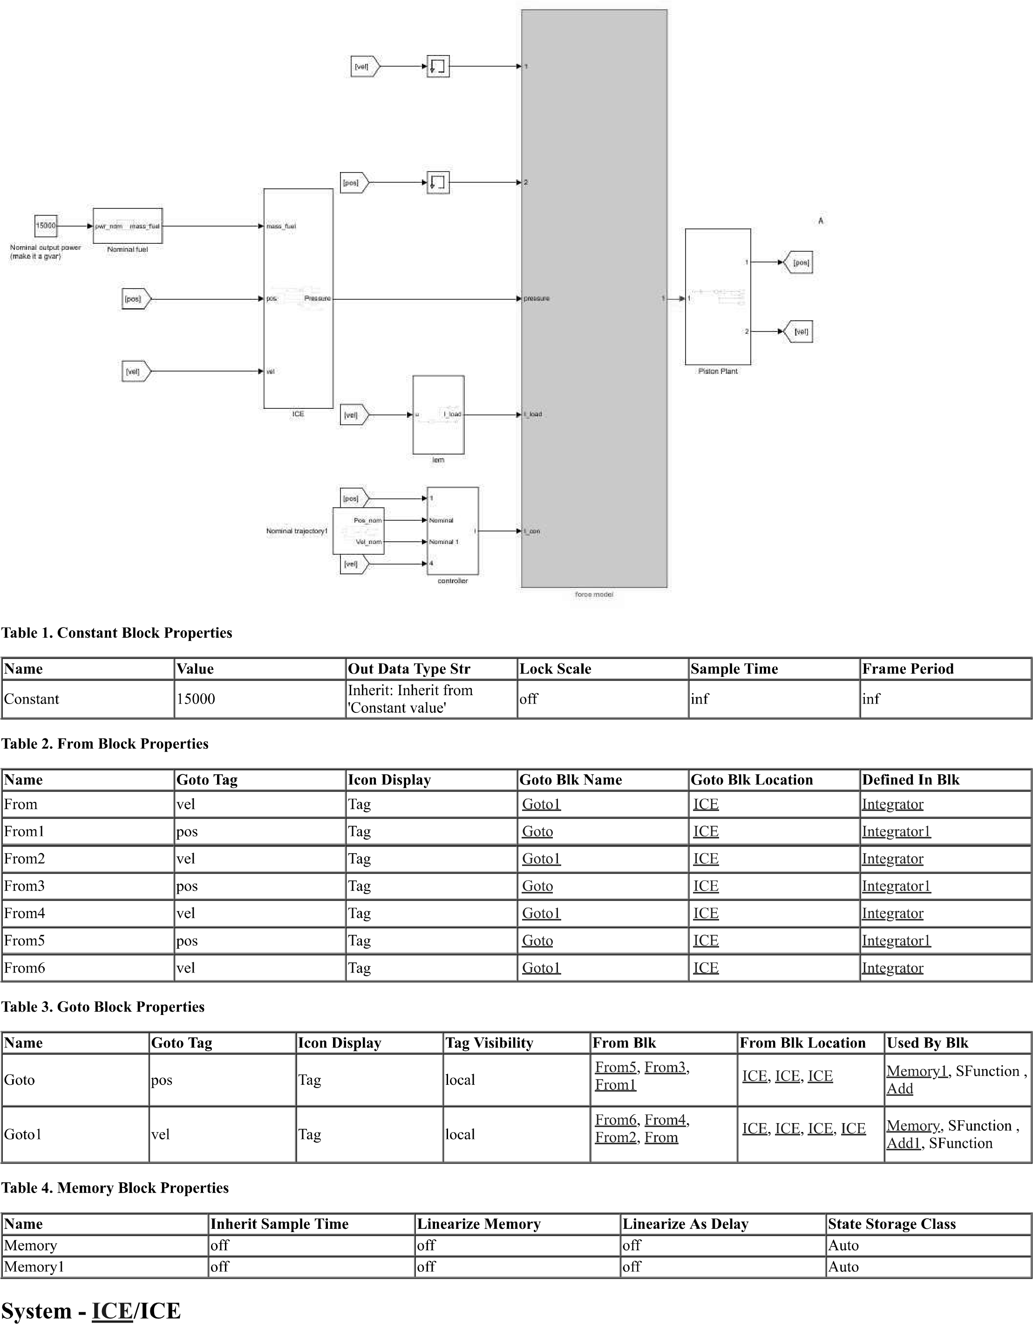

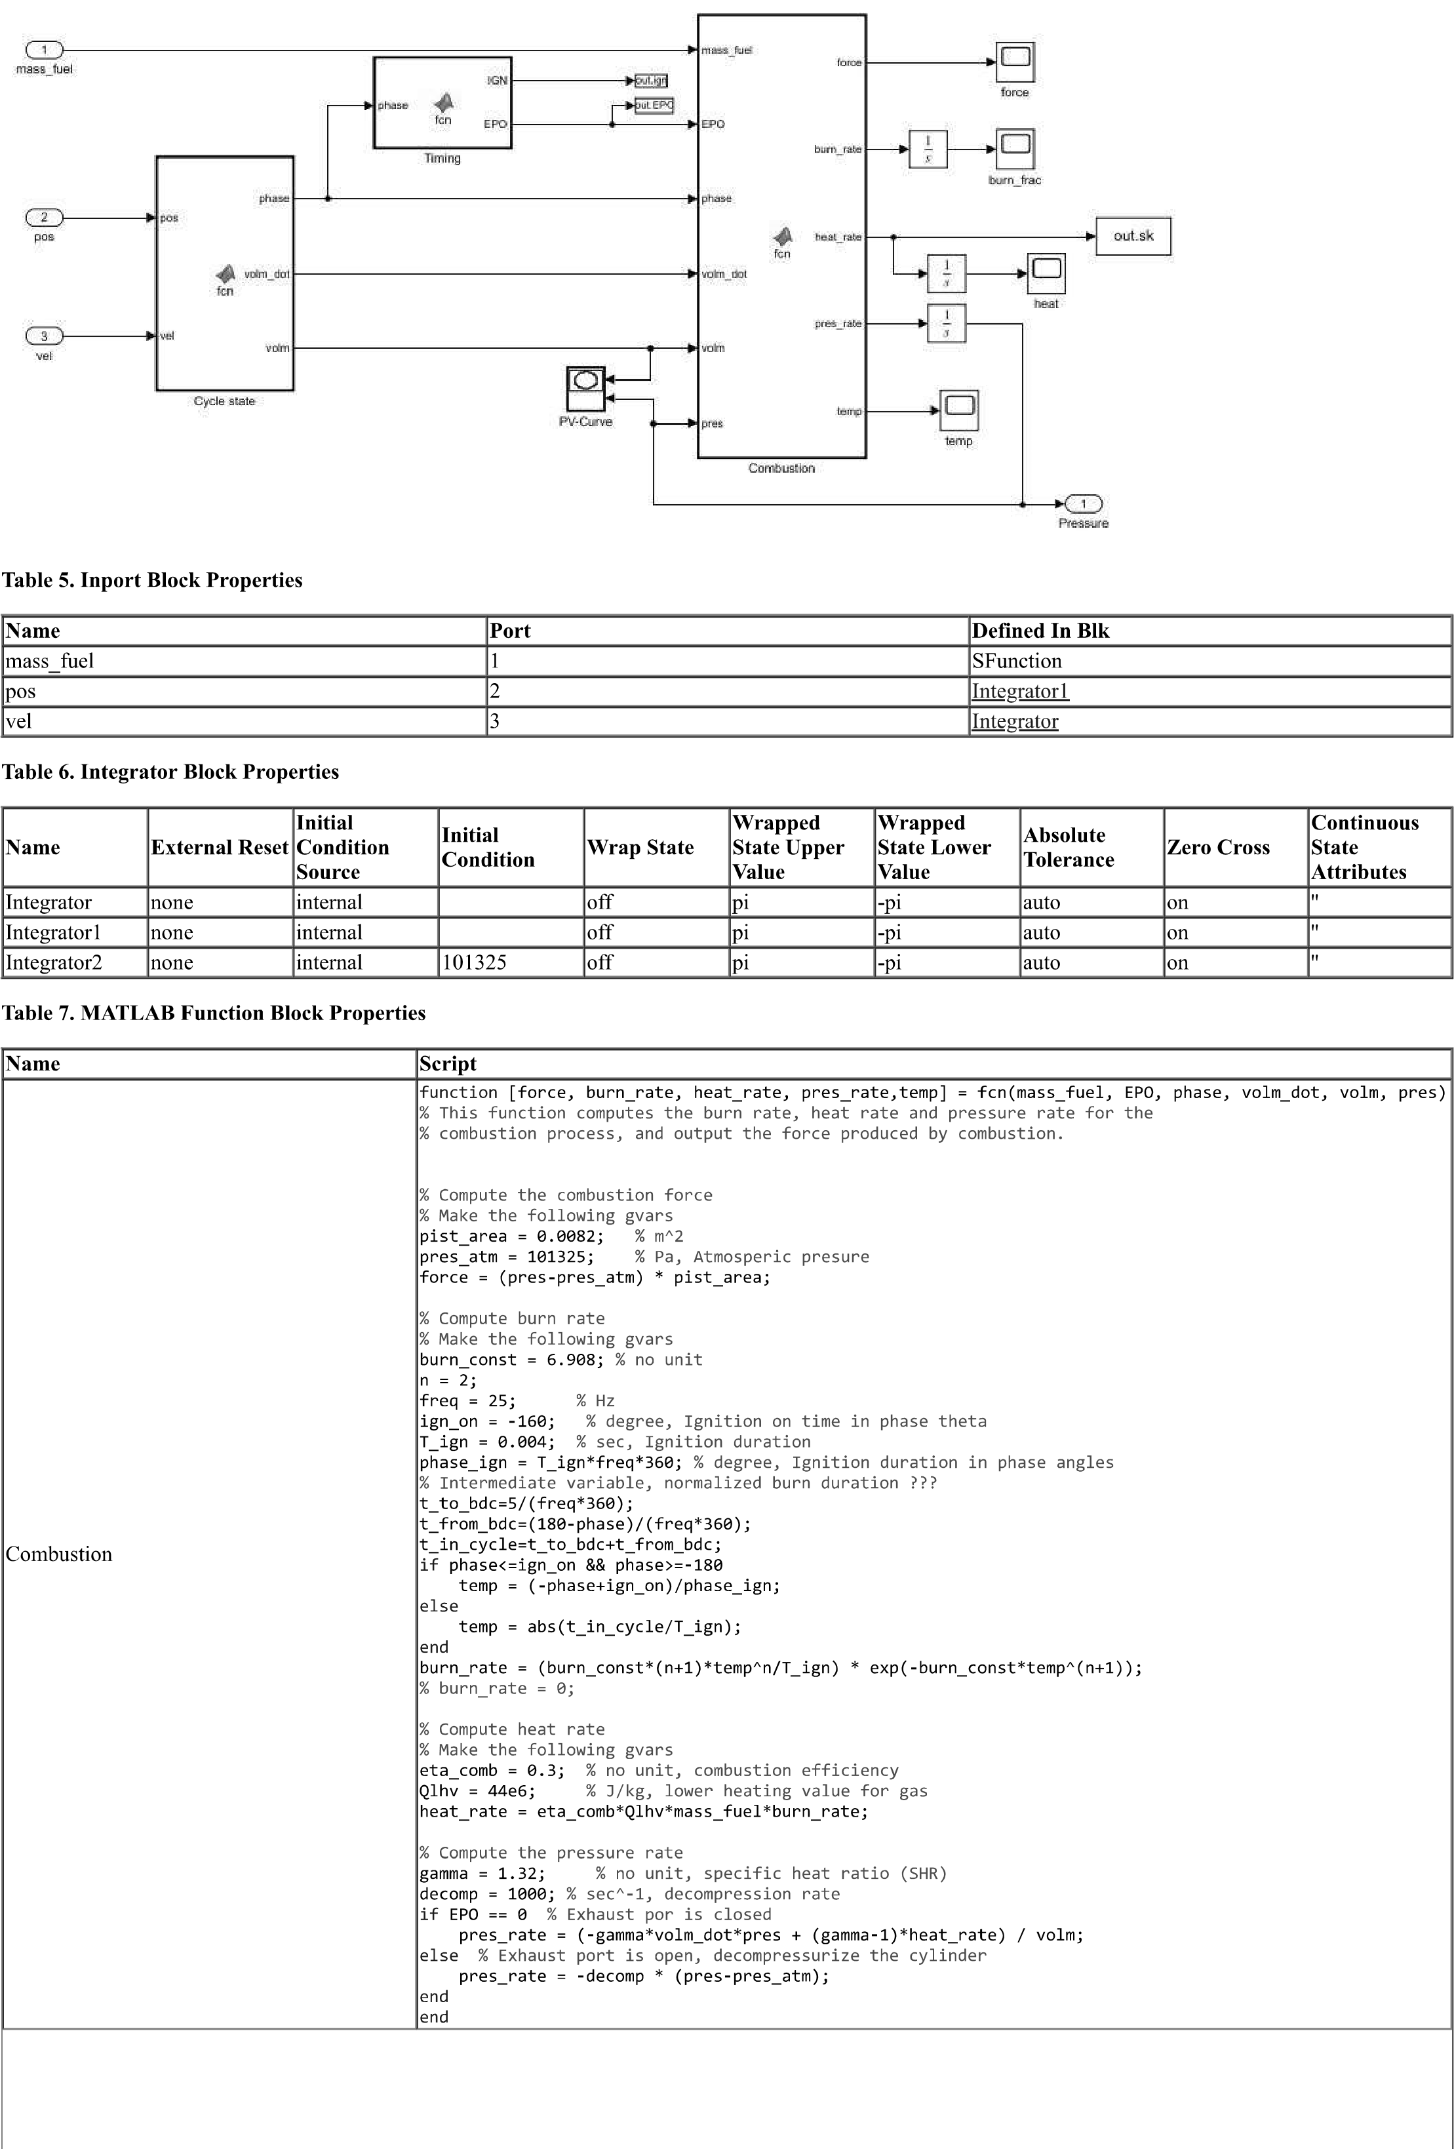

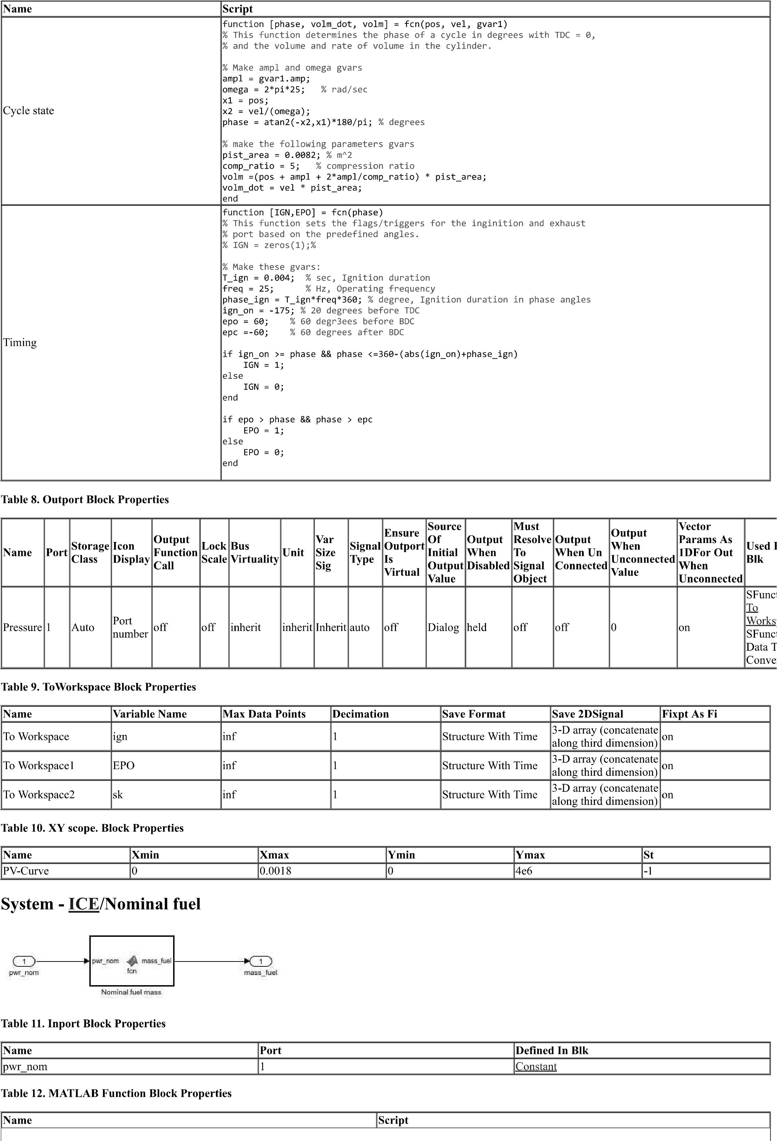

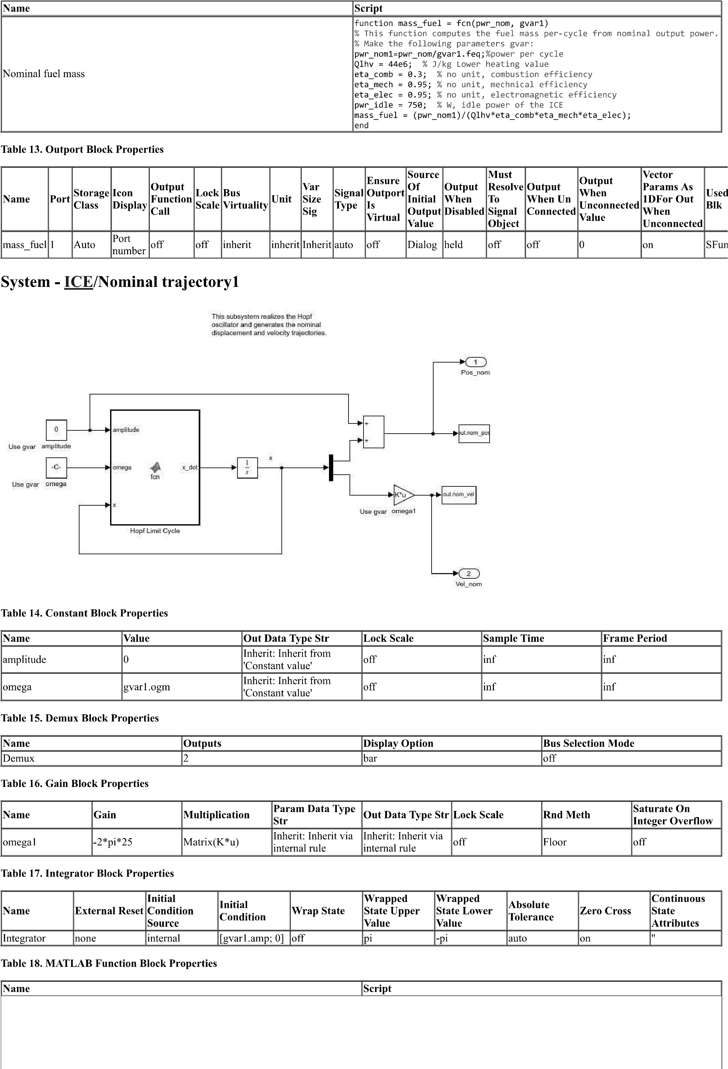

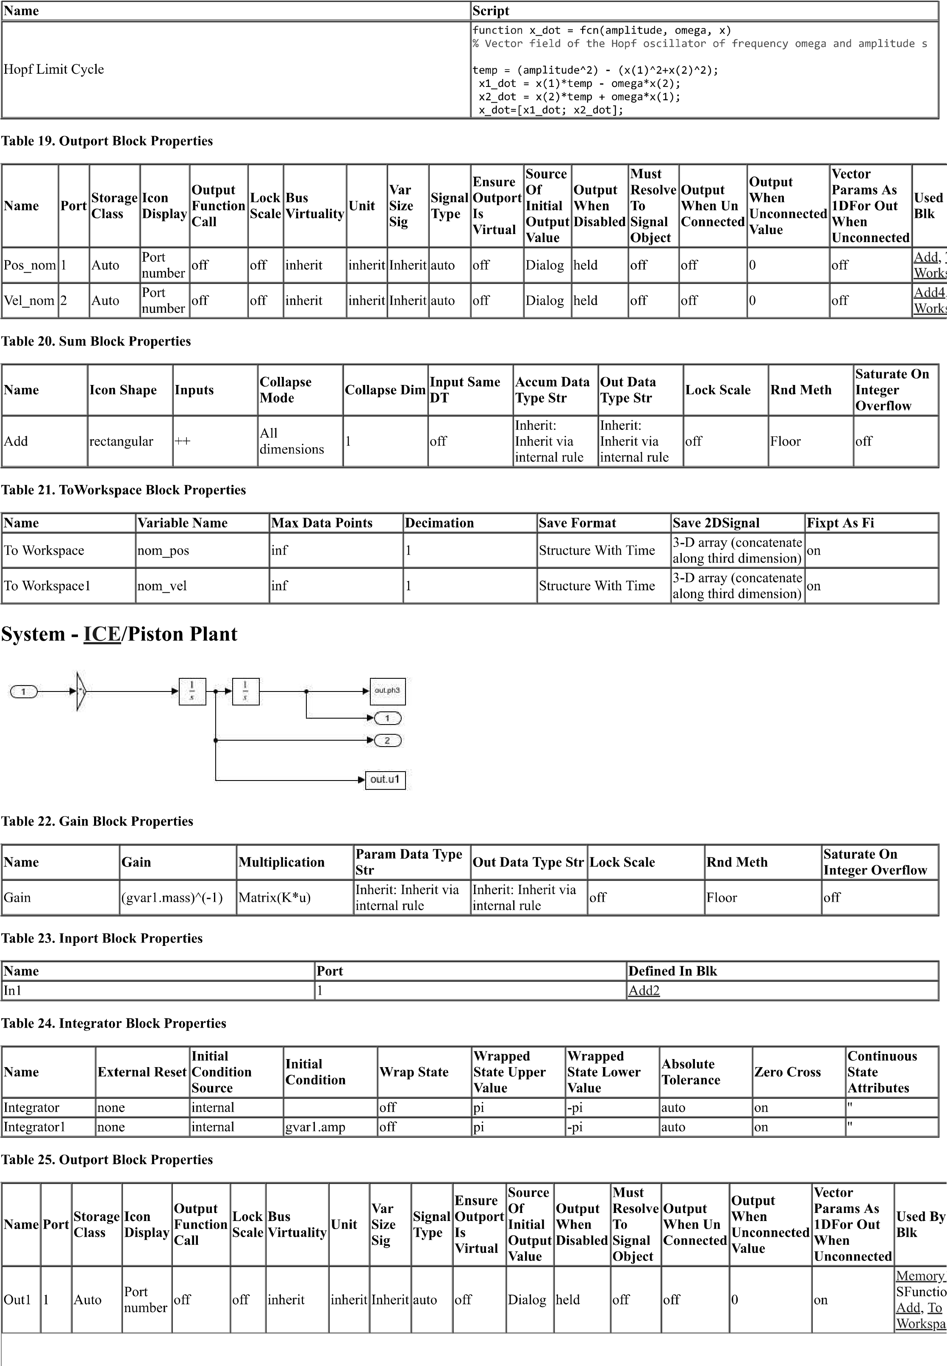

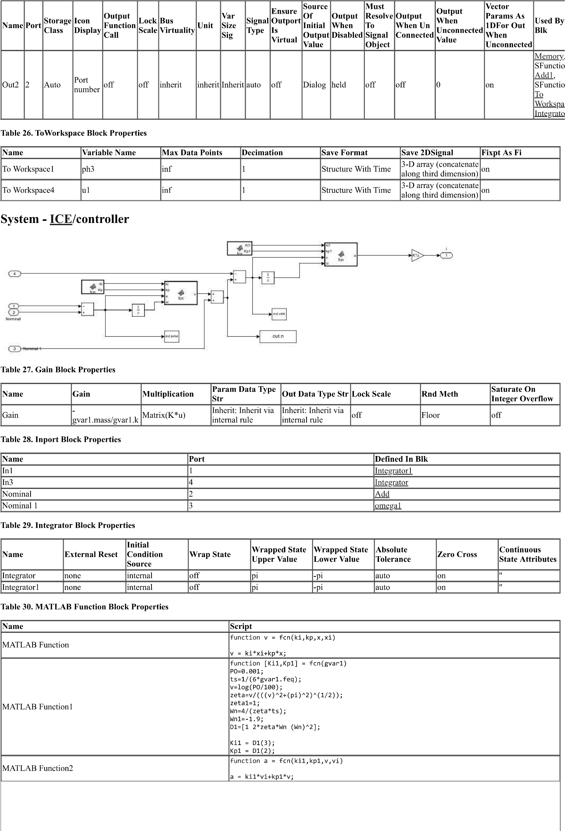

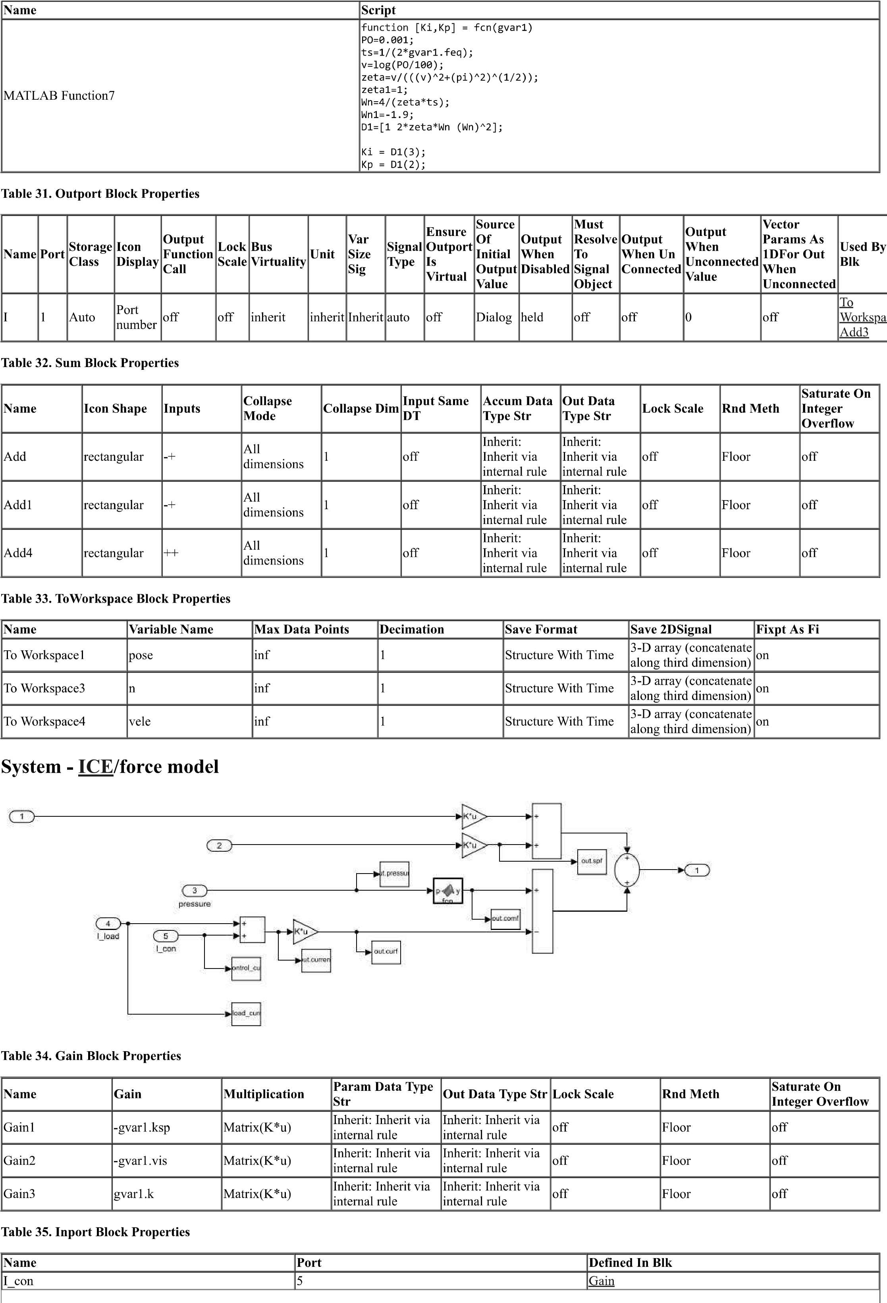

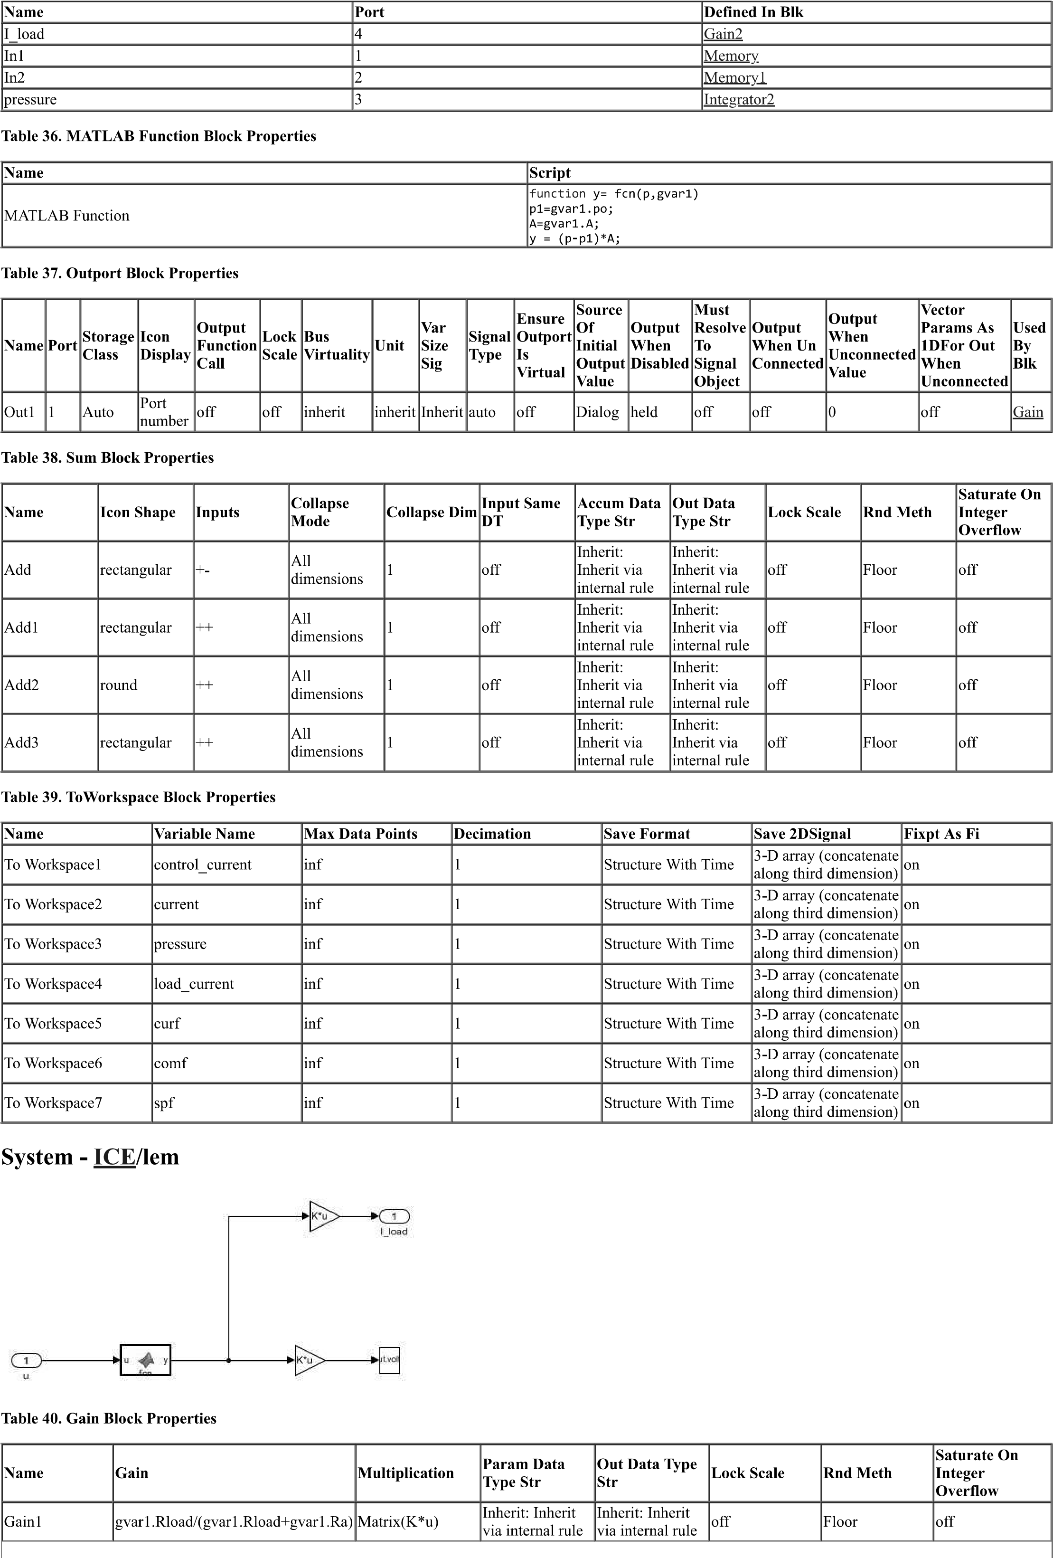

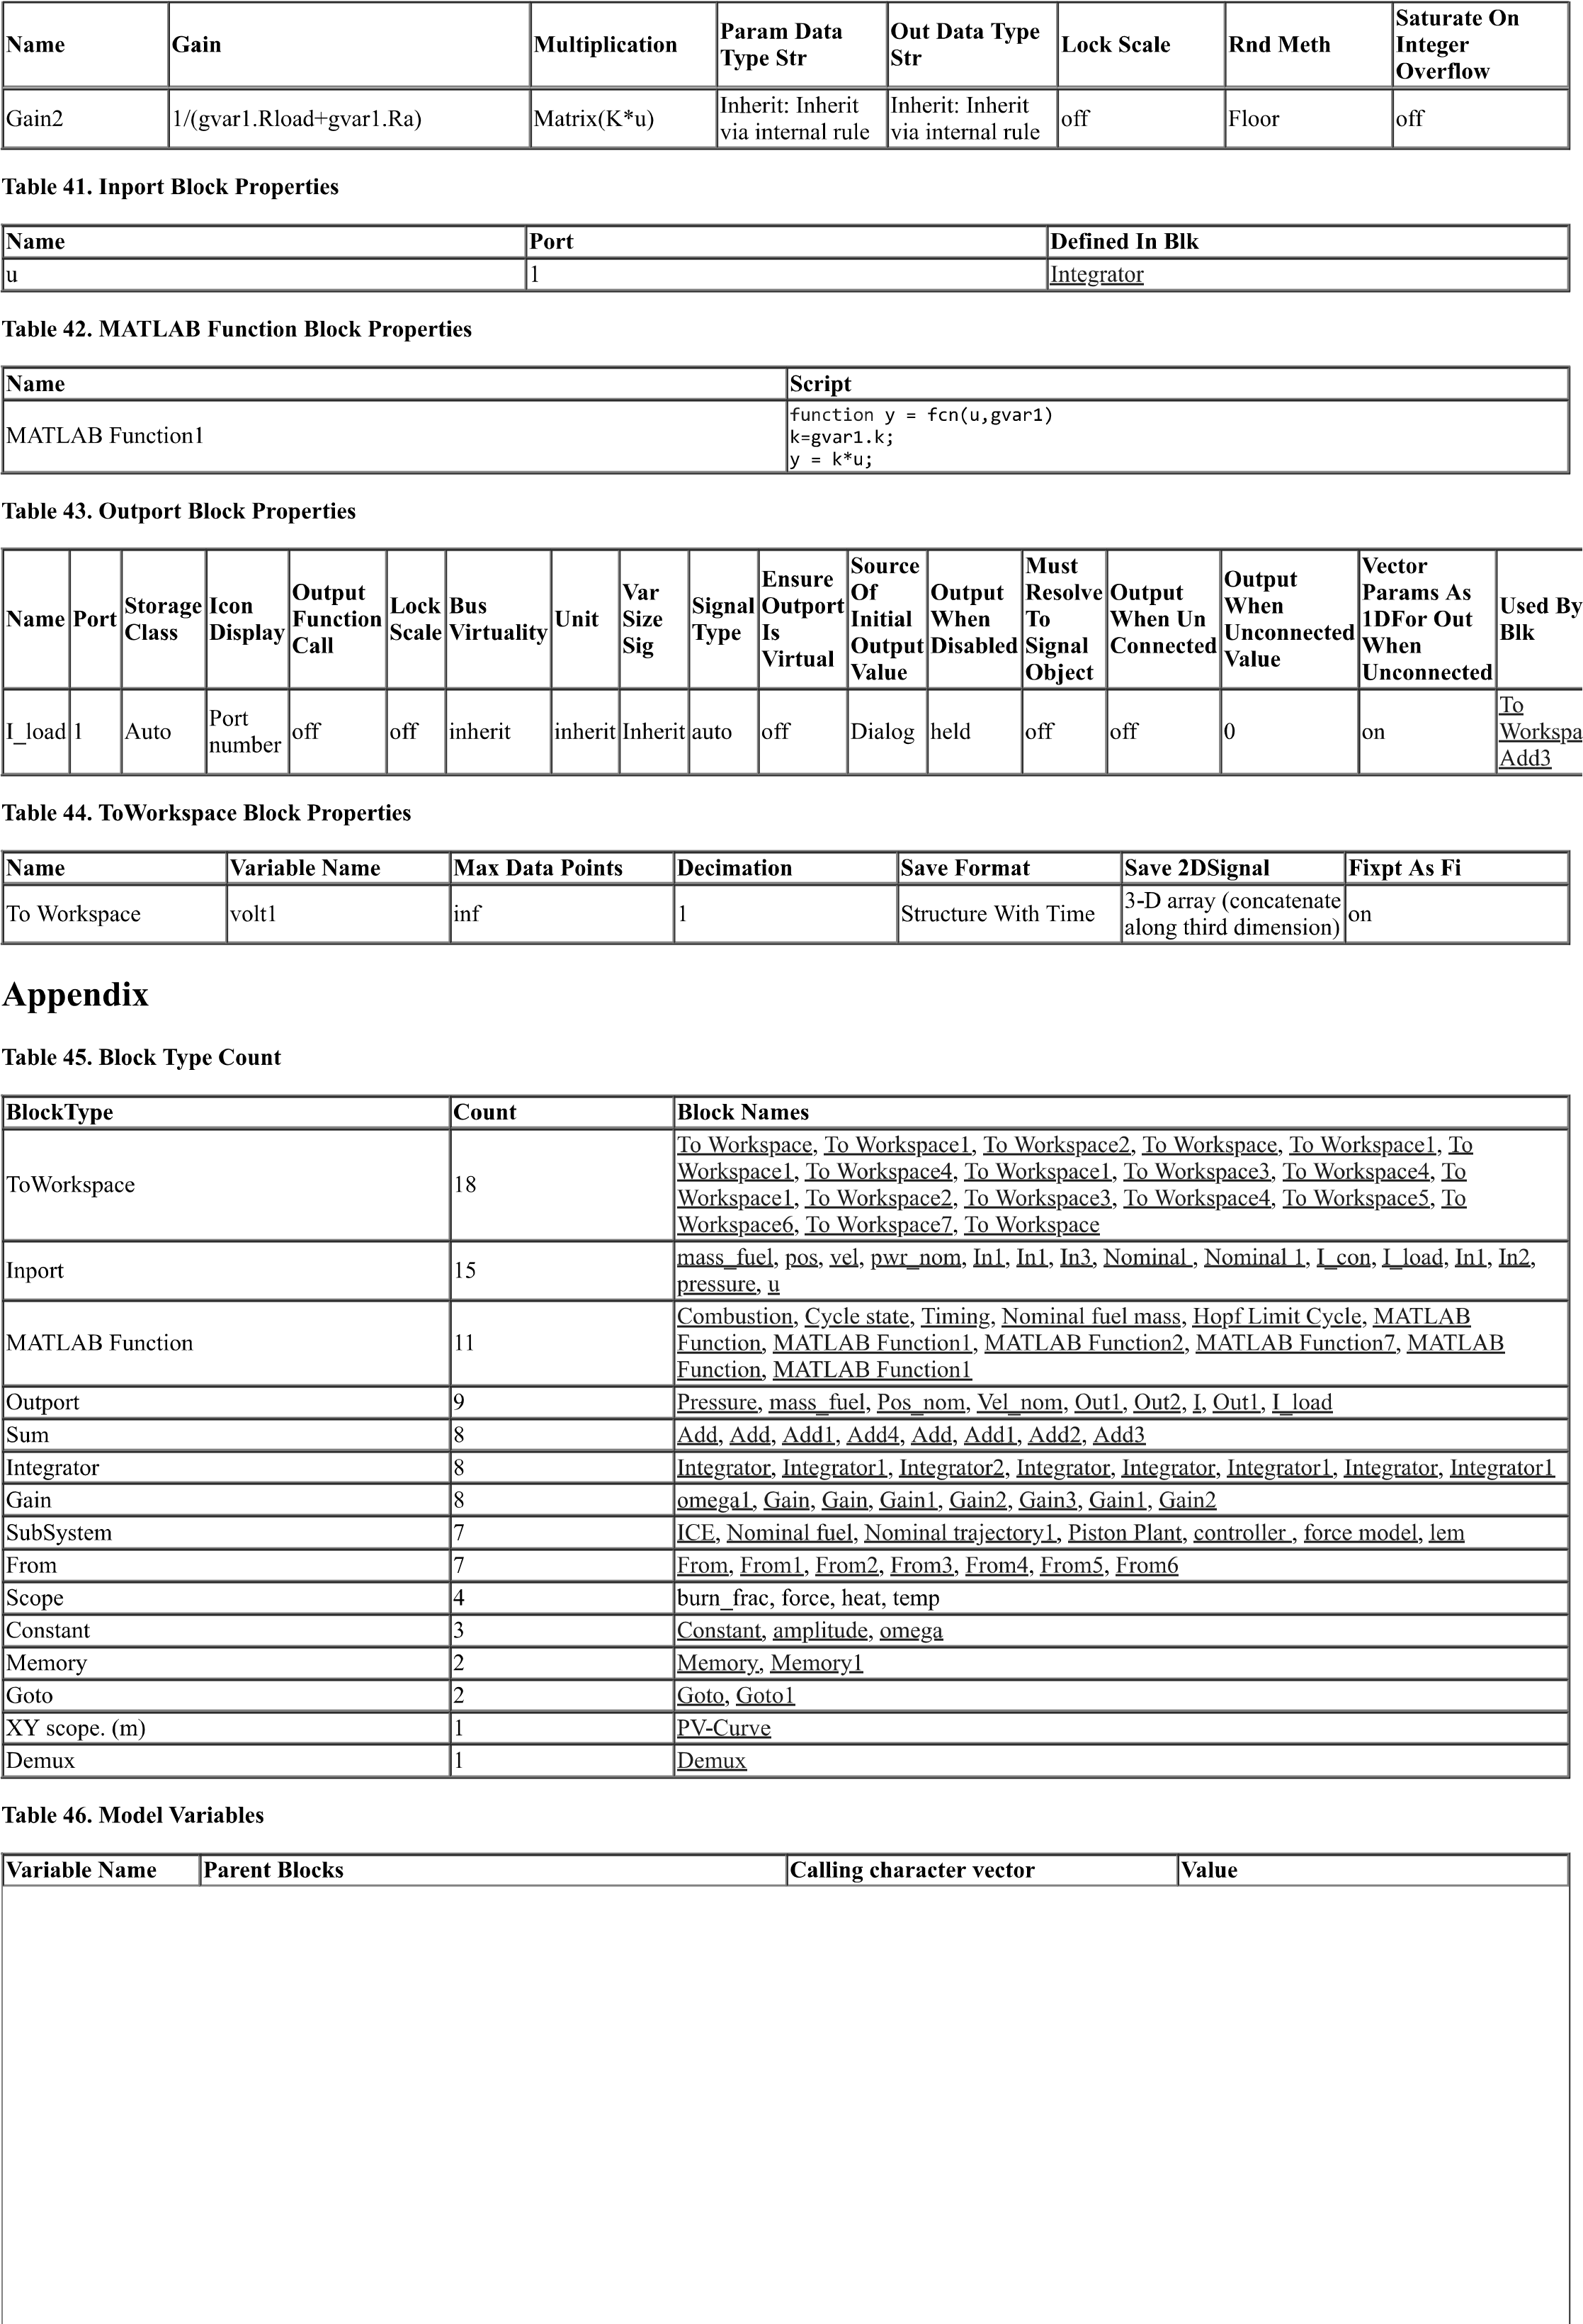

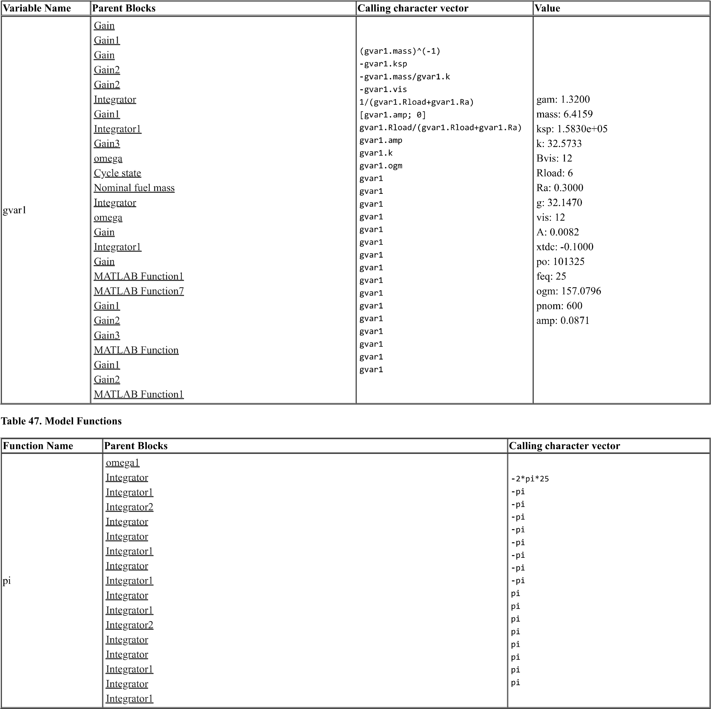

# 

# APPENDEX 2.1: MATLAB SCRIPT (INITIALIZATION SCRIPT)

clc;  
% Nominal output specs  
%  
% for x = 1:10  
% disp(x)  
% end  
%  
 % Nominal output power  
 P_nom = 15000; % W (Apparent power in VA)  
 % Nominal output voltage  
 V_nom = 300; % V (rms)  
 V_nom_pk = V_nom*sqrt(2); % V (peak)  
 % Nominal resistive load  
 R_load_nom = 6; % Ohm  
 % Nominal load current  
 I_nom = V_nom/R_load_nom; % A (rms)  
 I_nom_pk = I_nom*sqrt(2); % A (peak)  
 % Nominal frequency  
 freq = 25; % Hz  
 omega = 2*pi*freq; % rad/sec  
 % Nominal energy per cycle  
 W_load = P_nom/freq; % J  
  
% Physical constants  
 % Copper density  
 rho_cu = 8900; % kg/m^3  
 % Specific heat ratio  
 SHR = 1.32; % No units  
  
% Chosen design parameters  
 % Piston mass  
 mass_pist = 4; % kg  
 % Piston area  
 A_pist = 0.0082; % m^2  
 % Piston viscous friction constant  
 B_vis = 12; % N/(m/sec)  
 % Copper current density  
 sigma_cu = 6e6; % A/m^2  
 % Flux density  
 B = 1.0; % T  
  
% Designed parameters  
 % Armature wire cross-section area  
 A_cu = I_nom/sigma_cu; % m^2  
 %we will assume stroke length s  
 %The nominal RMS velocity will be V= s*omg/(2*sqrt(2))  
 %The thrust coefficient Km can be calculated as  
 %Wcyc=(c+km^2/(R_load+R_a)*V^2  
 %Km= B*L_cu  
 %M_cu=A_cu*L_cu*sigma_cu  
 %M=M_cu+M_pist  
 %K_sp=omg^2*M  
 % For simplicity, we will assume  
 R_a = 0.05 * R_load_nom; % ohm  
 E_ind_nom = (R_load_nom + R_a)*I_nom; % V (rms)  
 % Thus, vel_nom can be solved from the following quadradic equation  
 % mass_pist*vel_nom^2 + (rho_cu*A_cu*E_ind/B)*vel_nom - W_cyc = 0  
 %half stroke  
 amp=0.06;  
 % Nominal stroke  
 strk_nom = amp/sqrt(2);  
 %nominal rms velocity  
 vel_nom=strk_nom*omega;  
 % Electromagnetic coeffiencient  
 k_m = E_ind_nom/B/vel_nom; % N/A, V/(rad/sec)  
 % Copper mass  
 L_cu = k_m/B; % m  
 mass_cu = rho_cu*A_cu*L_cu; % kg  
 % Total mover mass  
 mass = mass_pist + mass_cu; % kg  
 % Spring stiffness coefficient  
 k_sp = mass * omega^2; % N/m  
  
% Global variable structure  
gvar1.gam = SHR;  
gvar1.mass = mass;  
gvar1.ksp = k_sp;  
gvar1.k = k_m;  
gvar1.Bvis = B_vis;  
gvar1.Rload = R_load_nom;  
gvar1.Ra =R_a;  
gvar1.g=32.147;  
gvar1.vis=12;  
gvar1.A=0.0082;  
gvar1.xtdc=-0.1;  
gvar1.po=101325;  
gvar1.A=0.0082;  
gvar1.feq=25;  
gvar1.ogm=2*pi*gvar1.feq;  
gvar1.pnom=W_load+gvar1.vis*(vel_nom)^2;  
gvar1.amp=strk_nom*sqrt(2);  
fsize = 16;  
sim('ICE')  
lwidth = 2; % line width  
figure(1)  
plot(ans.ph3.time(35000:45000),ans.ph3.signals.values(35000:45000,1),'g',...  
 ans.ign.time(35000:45000),-ans.ign.signals.values(35000:45000,1)*0.05,'r',...  
 ans.EPO.time(35000:45000),ans.EPO.signals.values(35000:45000,1)*0.05,'b','LineWidth', lwidth)  
xlabel('Time(s)','Fontsize', fsize)  
ylabel('position(m)','Fontsize', fsize)  
legend('poistion','ign','EPO')  
grid on  
axis square  
figure(2)  
plot(ans.ph3.signals.values(:,1)*A_pist,ans.pressure.signals.values(:,1),'r','LineWidth', lwidth)  
xlabel('position(m)','Fontsize', fsize)  
ylabel('pressure(pa)','Fontsize', fsize)  
grid on  
axis square  
figure(3)  
plot(ans.curf.time,-ans.curf.signals.values(:,1),'b',...  
 ans.comf.time,ans.comf.signals.values(:,1),'r',...  
 ans.spf.time,ans.spf.signals.values(:,1),'LineWidth', lwidth)  
legend('current force', 'combustion force','spring_force')  
xlabel('time(s)','Fontsize', fsize)  
ylabel('force(N)','Fontsize', fsize)  
grid on  
axis square  
run('op.m')

# APPENDEX 2.2 MATLAB *SCRIPT (*OUTPUT SCRIPT)

